|  |  |
| --- | --- |
| A picture of a winding road and trees  COVID 19 SECOND WAVE dATA aNALYSIS | Abstract  this Document describes COVID 19 SECOND WAVE dATA organised by different REPORTS    Suhas Aggarwal   |

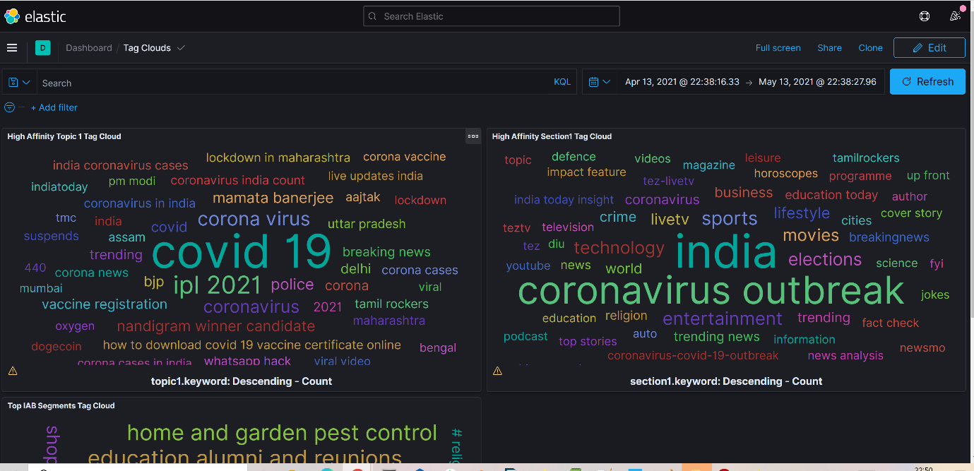

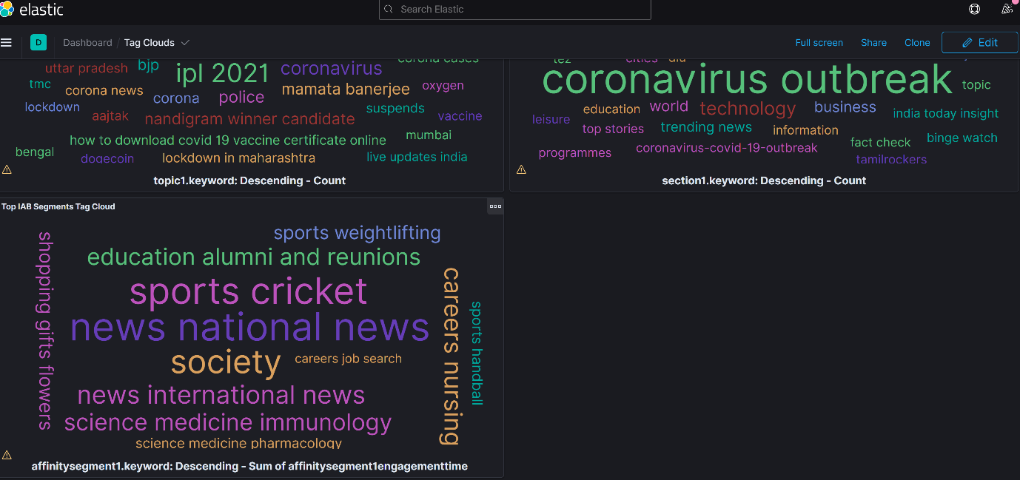

**Three Tag clouds for covid 19 pandemic second wave –**

**1)Top Topics in which users showed highest engagement.**

**2)Top Sections in which users showed highest engagement.**

**3)Top IAB segments in which users showed highest engagement.**

Tag cloud Graphs can be filtered by different data points.

1)Top Tag clouds section wise

2)Top Tag clouds IAB segment wise

3)Top Tag clouds topic wise

4)Top Tag clouds by loyalty type

6)Top Tag clouds by website – Aajtak/Indiatoday

**Top Topics during pandemic second wave – (Detailed drilldown Is Available at url)**

|  |  |
| --- | --- |
| covid 19 | 1,821,479 |
| ipl 2021 | 709,165 |
| corona virus | 437,157 |
| coronavirus | 323,451 |
| police | 237,969 |
| nandigram winner candidate | 218,660 |
| mamata banerjee | 212,206 |
| bjp | 176,503 |
| covid | 173,783 |
| corona | 134,365 |

**Top Sections during pandemic second wave-**

|  |  |
| --- | --- |
| india | 3,532,661 |
| coronavirus outbreak | 2,761,271 |
| sports | 730,416 |
| entertainment | 678,820 |
| elections | 637,885 |
| technology | 623,708 |
| movies | 557,054 |
| livetv | 437,811 |
| lifestyle | 405,121 |
| business | 295,328 |

**Top IAB segments during pandemic second wave –**

|  |  |
| --- | --- |
| art and entertainment movies and tv bollywood | 246,207,208 |
| religion and spirituality hinduism | 182,666,773 |
| technology and computing software desktop video | 63,750,386 |
| news national news | 38,561,058 |
| sports cricket | 26,395,951 |
| art and entertainment movies and tv tamil movies | 26,104,085 |
| society | 11,948,561 |
| health and fitness disease gerd and acid reflux | 6,702,747 |
| food and drink cuisines indian cuisine | 3,594,969 |
| art and entertainment movies and tv telugu movies | 3,286,991 |

**Report 1 –**

**i)Top Brands by User count( During covid pandemic second Wave)**

|  |  |
| --- | --- |
| Xiaomi | 203,550 |
| Samsung | 199,880 |
| Apple | 106,889 |
| Vivo | 66,045 |
| OPPO | 59,929 |
| OnePlus | 49,931 |
| Realme | 44,930 |
| Motorola | 21,939 |
| Huawei | 20,537 |
| Nokia | 12,370 |

**Report 2 –**

**ii)Top Brands sorted by users Having high visiting volume ( Loyal Category)**

|  |  |
| --- | --- |
| Jivi | 5,284 |
| iBall | 4,936 |
| Comio | 4,815 |
| Essential | 4,791 |
| Spice | 4,768 |
| Neffos | 4,731 |
| Colors | 4,664 |
| Razer | 4,658 |
| Xtouch | 4,656 |
| LeEco | 4,644 |
| HTC | 4,613 |
| Yu | 4,611 |
| RIM | 4,605 |
| OPPO | 4,584.451 |
| Infinix | 4,573 |
| Asus | 4,557 |
| Xiaomi | 4,555.908 |
| OnePlus | 4,555.654 |
| Realme | 4,554.208 |
| Panasonic | 4,554 |

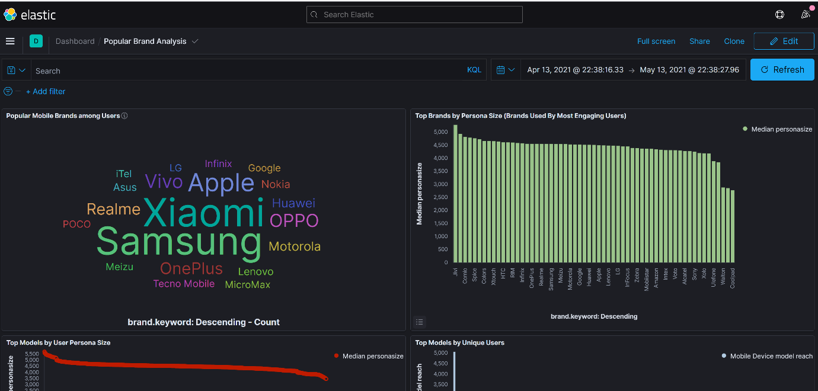

Top 20 Models by User Persona Size

|  |  |
| --- | --- |
| Lenovo TAB3 8 | 5,687 |
| iTel A40 | 5,577 |
| Xiaomi MI MAX | 5,569 |
| iBall Slide Spirit V2 | 5,557 |
| LG K42 | 5,553 |
| Comio C1 Pro | 5,476 |
| Huawei Honor P30 Pro | 5,469 |
| Huawei P40 Lite | 5,448 |
| Lenovo K12 Note | 5,439 |
| Tecno Mobile Pouvoir 3 Plus | 5,422 |
| Samsung Galaxy Fold | 5,415 |
| OPPO R15 | 5,413 |
| OPPO Reno A | 5,413 |
| Sony Xperia M2 Dual | 5,398 |
| Motorola Moto E2 | 5,387 |
| Realme X50 Pro 5G | 5,383 |
| Huawei Mate 30 Pro 5G | 5,378 |
| Vivo 1920 20 | 5,368 |
| POCO X3 NFC | 5,355 |
| Motorola Moto G9 Play | 5,354 |

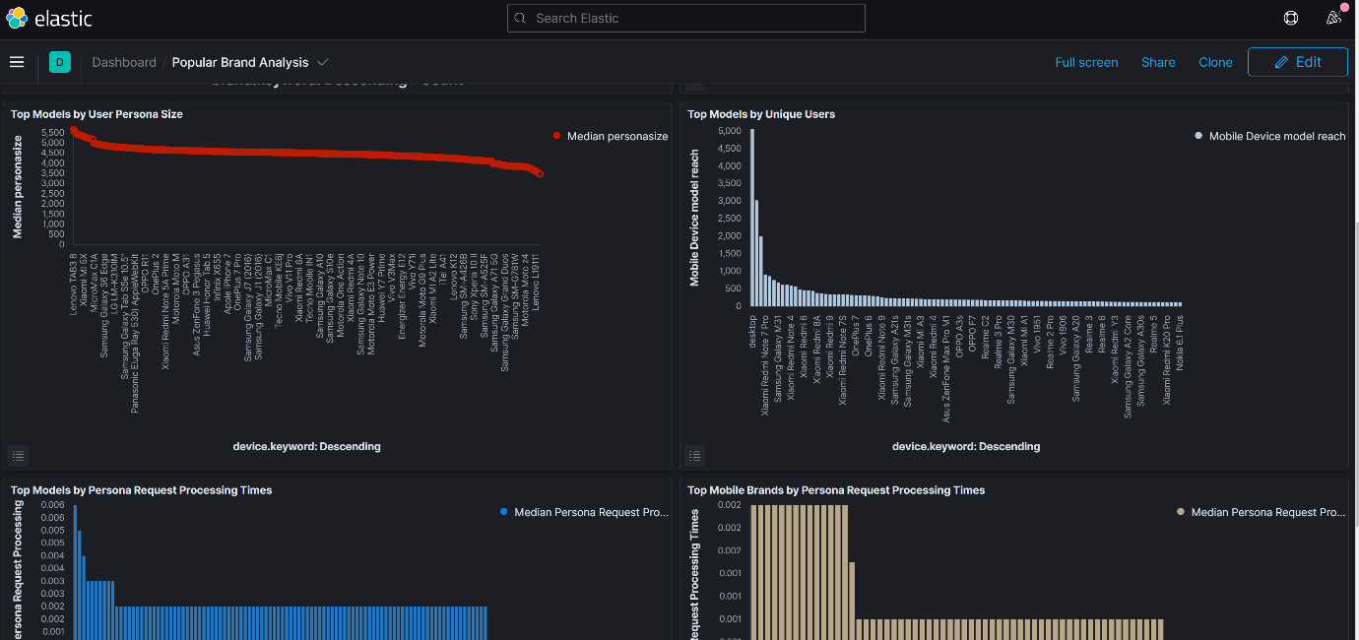

**Top 20 Models by Unique Users**

|  |  |
| --- | --- |
| desktop | 5,166 |
| Apple iPhone | 3,037 |
| smartphone | 2,021 |
| Xiaomi Redmi Note 7 Pro | 915 |
| Xiaomi Redmi Note 5 Pro | 871 |
| Xiaomi Redmi Note 9 Pro | 754 |
| Samsung Galaxy M31 | 691 |
| Xiaomi Redmi Note 8 Pro | 624 |
| Apple | 621 |
| Xiaomi Redmi Note 4 | 607 |
| Xiaomi Redmi Note 8 | 572 |
| Samsung Galaxy M30s | 487 |
| Xiaomi Redmi 6 | 472 |
| Samsung Galaxy M21 | 463 |
| Samsung Galaxy J7 Prime | 445 |
| Xiaomi Redmi 8A | 385 |
| OnePlus Nord 5G | 377 |
| Xiaomi Redmi Note 6 Pro | 362 |
| Samsung Galaxy A50 | 346 |
| Xiaomi Redmi 9 | 346 |

**Top 20 Models by User Persona Request Processing Times**

|  |  |
| --- | --- |
| Samsung Galaxy Grand Duos | 0.006 |
| Lenovo Vibe P1 | 0.005 |
| LG LM-K315IM | 0.004 |
| Asus ZenFone 5 | 0.003 |
| Huawei Mate 30 Pro 5G | 0.003 |
| LG K50S | 0.003 |
| Lenovo Tab E8 | 0.003 |
| Panasonic Eluga I6) AppleWebKit | 0.003 |
| Samsung Galaxy S III | 0.003 |
| Samsung SM-A015T1 | 0.003 |
| Alcatel 1S | 0.002 |
| Alcatel 3X (2019) | 0.002 |
| Alcatel A3 | 0.002 |
| Amazon Fire HD 10 (2017) | 0.002 |
| Amazon Fire HD 8 (2017) | 0.002 |
| Amazon Fire HD 8 (2018) | 0.002 |
| Apple iPhone 12 Mini | 0.002 |
| Apple iPhone 12 Pro | 0.002 |
| Apple iPhone 6 | 0.002 |
| Apple iPhone 7 Plus | 0.002 |

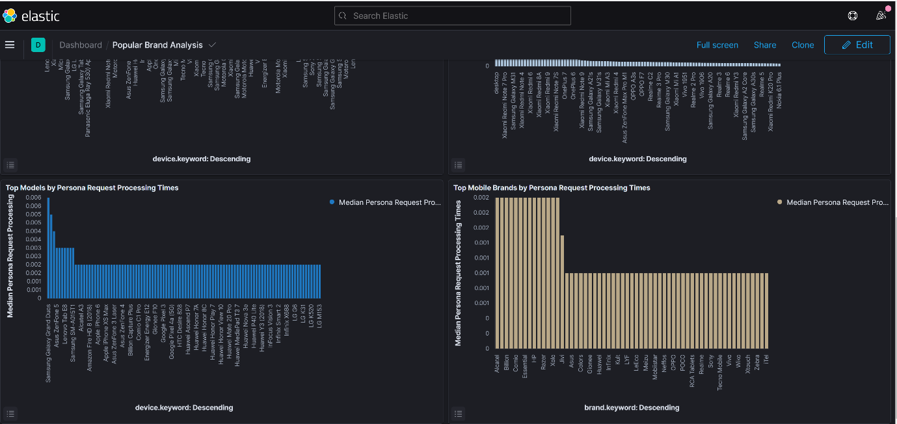

**Top Mobile brands by User Persona Request Processing Times**

|  |  |
| --- | --- |
| Alcatel | 0.002 |
| Amazon | 0.002 |
| Billion | 0.002 |
| Cherry Mobile | 0.002 |
| Comio | 0.002 |
| Energizer | 0.002 |
| Essential | 0.002 |
| Foxconn | 0.002 |
| HP | 0.002 |
| HTC | 0.002 |
| Razer | 0.002 |
| Walton | 0.002 |
| Xolo | 0.002 |
| ZTE | 0.002 |
| Jivi | 0.002 |
| Apple | 0.001 |
| Asus | 0.001 |
| Blu | 0.001 |
| Colors | 0.001 |
| Coolpad | 0.001 |

**Top Clients (in Descending order of Persona Size) (Heavy/More loyal Users tend to follow this order)**

|  |  |
| --- | --- |
| Chrome 76.0.3809.132 | 5,687 |
| HeyTapBrowser 15.7.4.1 | 5,635 |
| UC Browser 12.11.5.1185 | 5,615 |
| Chrome 69.0.3497.100 | 5,557 |
| Opera Mobile 55.2.2719.50740 | 5,554 |
| Opera Mobile 62.1.3146.57513 | 5,487 |
| vivo Browser 6.6.0.1 | 5,452 |
| Baidu Box App 5.5.0.10 | 5,451 |
| Chrome 86.0.4240.185 | 5,448 |
| Chrome Webview 81.0.4044.111 | 5,445 |
| Chrome Webview 84.0.4147.111 | 5,442 |
| Microsoft Edge 46.01.2.5140 | 5,415 |
| Opera Mobile 54.3.2672.50220 | 5,412 |
| Chrome Mobile 66.0.3359.106 | 5,396 |
| Opera Mobile 51.2.2461.138619 | 5,392 |
| Chrome Mobile 72.0.3626.76 | 5,378 |
| Chrome Webview 86.0.4240.75 | 5,357 |
| Huawei Browser 11.0.6.305 | 5,354 |
| UC Browser 12.13.4.1214 | 5,353 |
| UC Browser 12.12.3.1218 | 5,338 |

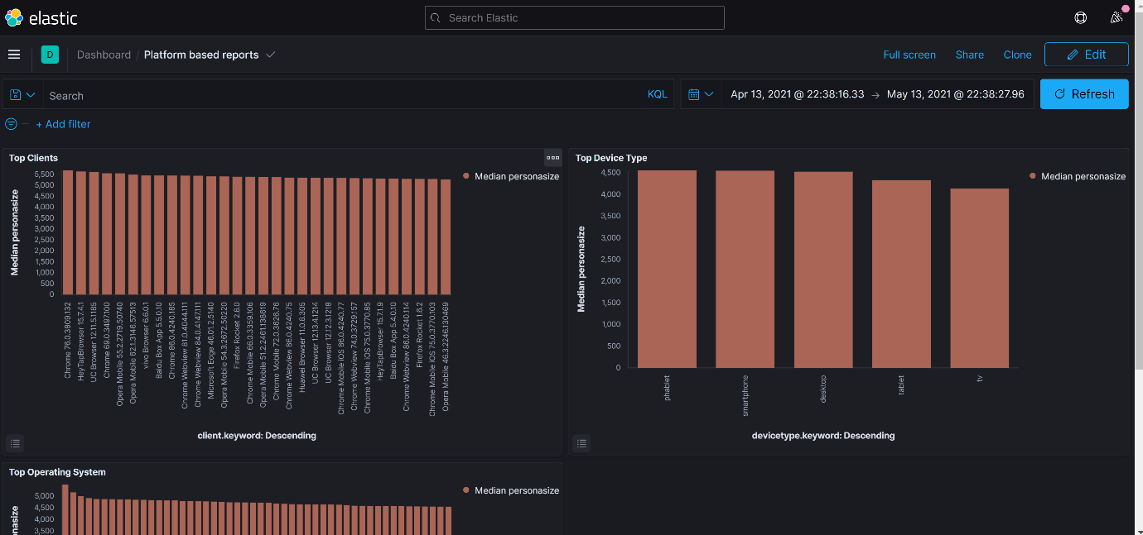

**Top device types (in Descending order of Persona Size) (Heavy/More loyal Users tend to follow this order)**

|  |  |
| --- | --- |
| phablet | 4,554.255 |
| smartphone | 4,547.094 |
| desktop | 4,521.075 |
| tablet | 4,331.982 |
| tv | 4,135 |

**Top Operating System**

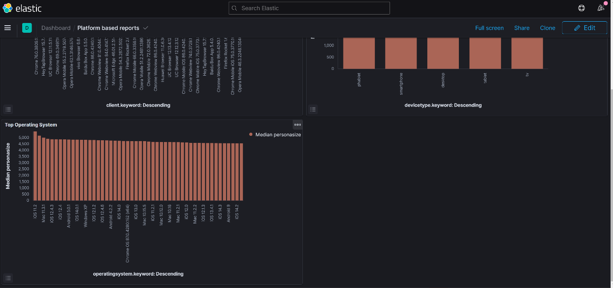

**Top Operating System (in Descending order of Persona Size) (Heavy/More loyal Users tend to follow this order)**

|  |  |
| --- | --- |
| iOS 11.2 | 5,495 |
| Mac 10.10.1 | 5,163 |
| Mac 11.3.1 | 4,999 |
| iOS 13.5.1 | 4,917 |
| iOS 12.4.3 | 4,878 |
| iOS 11.4 | 4,877 |
| iOS 12.4 | 4,873 |
| iOS 11.0.3 | 4,862 |
| Android 5.0.1 | 4,851 |
| iOS 12.3.1 | 4,845 |
| iOS 14.0.1 | 4,844 |
| iOS 13.3.1 | 4,836 |
| Windows XP | 4,824 |
| Mac 10.12.2 | 4,817 |
| iOS 12.1.2 | 4,817 |
| iOS 11.2.6 | 4,794 |
| iOS 12.4.6 | 4,788 |
| Mac 10.12.3 | 4,783 |
| Android 4.2.2 | 4,776 |
| iOS 14.2.1 | 4,767 |

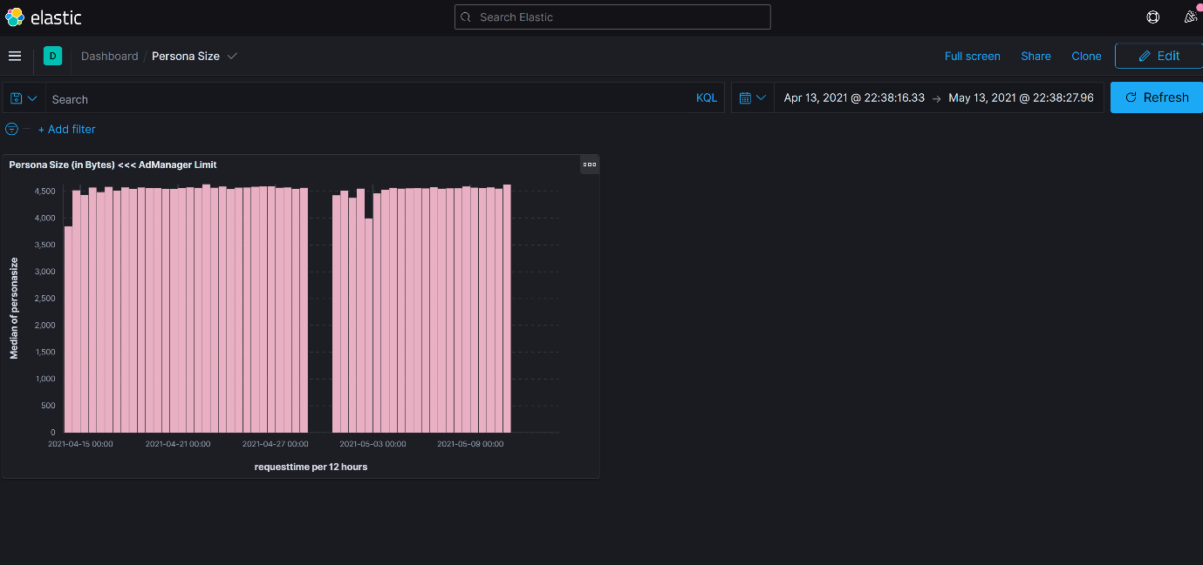

**Distribution of Persona Sizes throughout the day (Size is mentioned in Kb)**

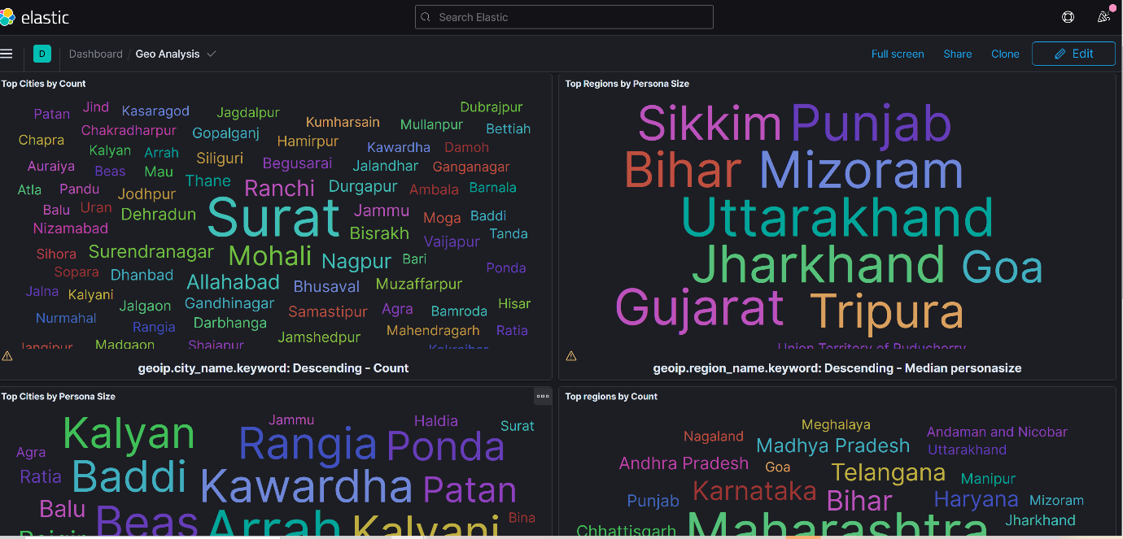

1)Top Cities in the tag cloud (corresponding to covid 19 second wave)

**(Surat(in Gujarat) was badly affected city during COVID-19)**

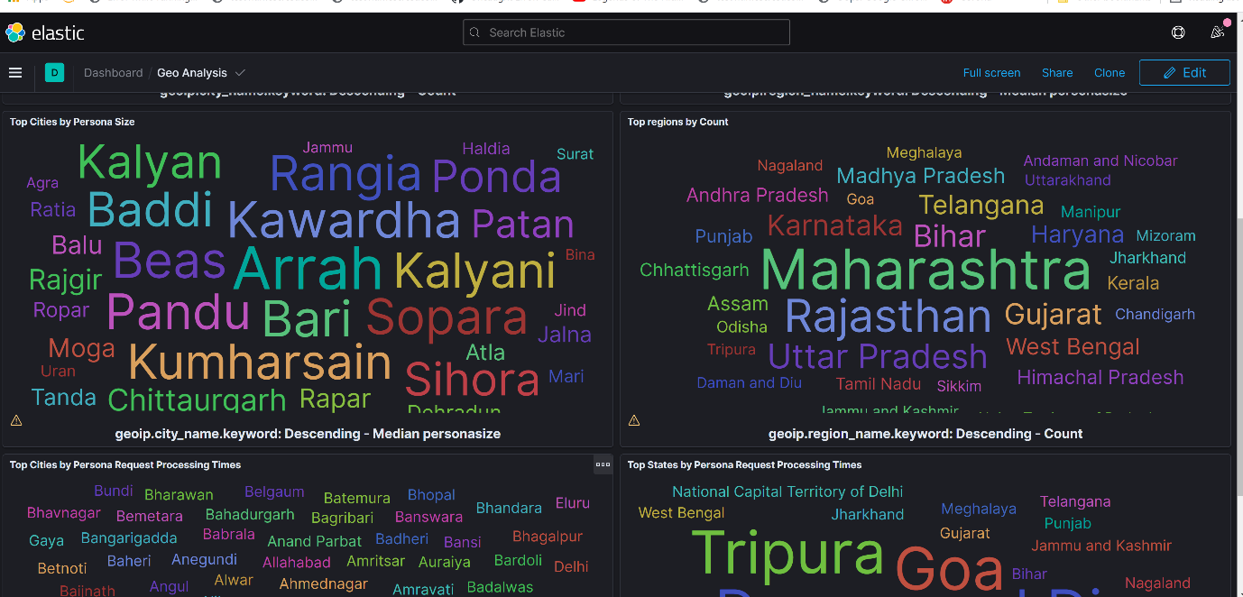

2)Top cities by persona size in the tag cloud (corresponding to covid 19 second wave)

3)Top States in the tag cloud (corresponding to covid 19 second wave)

**Maharashtra is worst-hit state of COVID 19 and is showing high user activity during this period.**

Region Graphs can be filtered by different data points.

1)Top Region section wise

2)Top Region IAB segment wise

3)Top Region topic wise

4)Top Region by loyalty type

6)Top Region by website – Aajtak /Indiatoday

**Color Persona of user (Covid 19 pandemic second wave)**

These colors are in order of importance during (Covid 19 pandemic second wave)

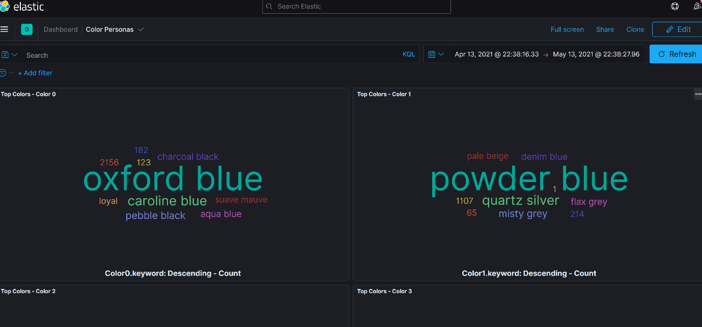

-

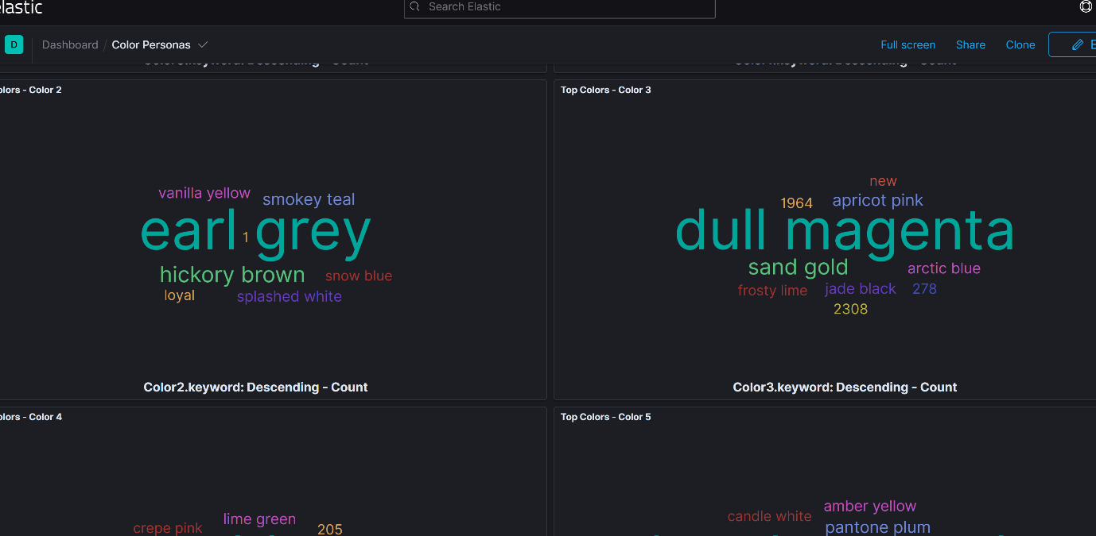

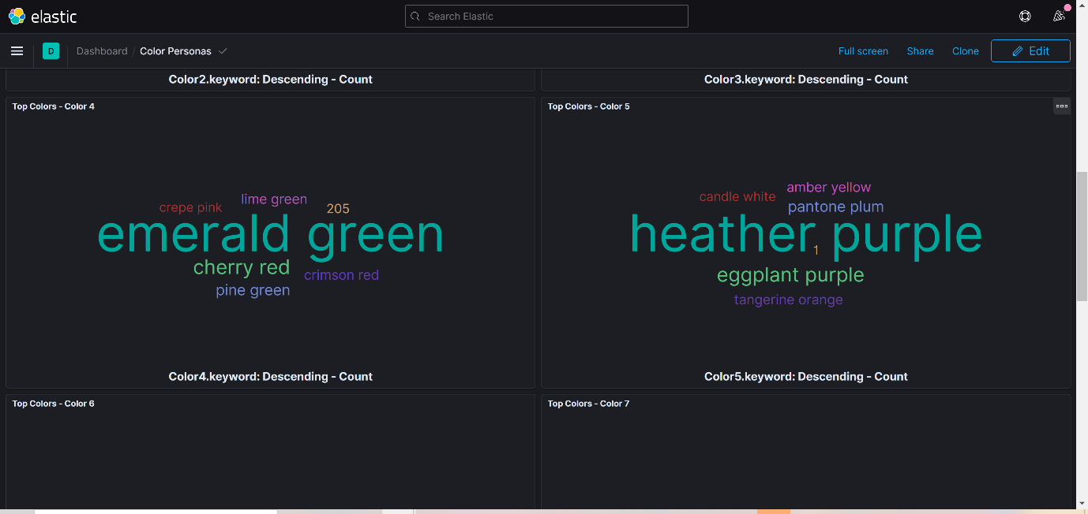

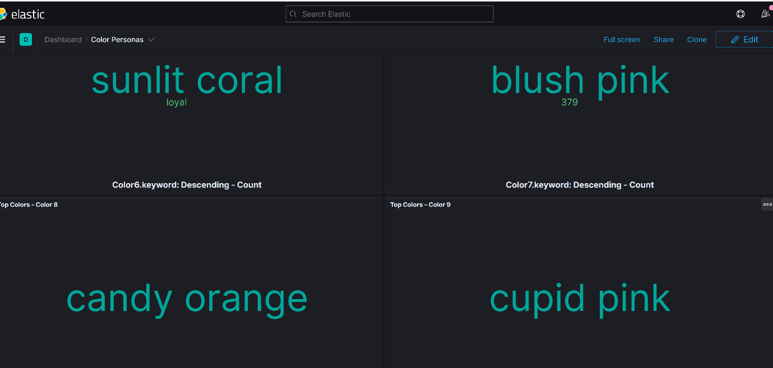

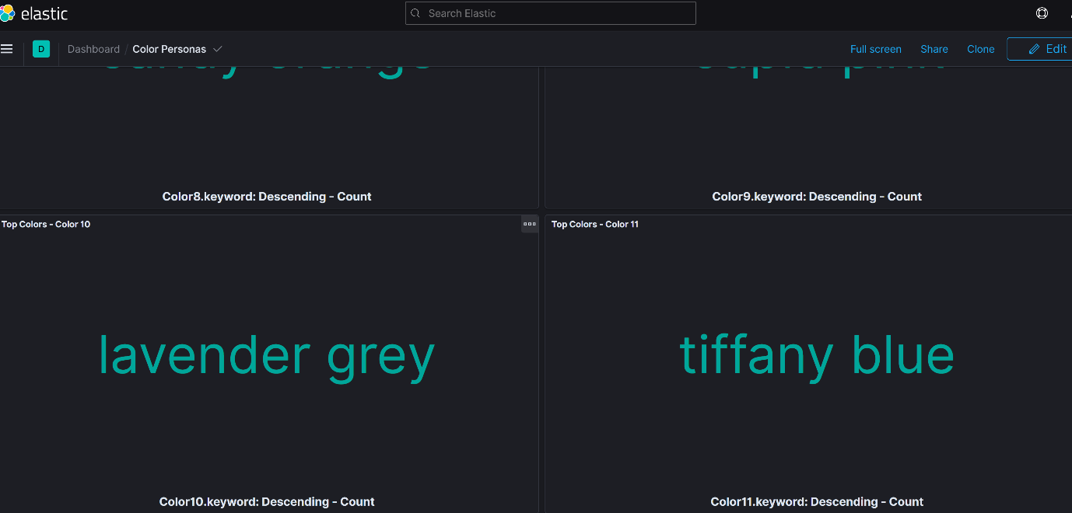

**User behavioral/Categorical affinities (Covid 19 pandemic second wave)**

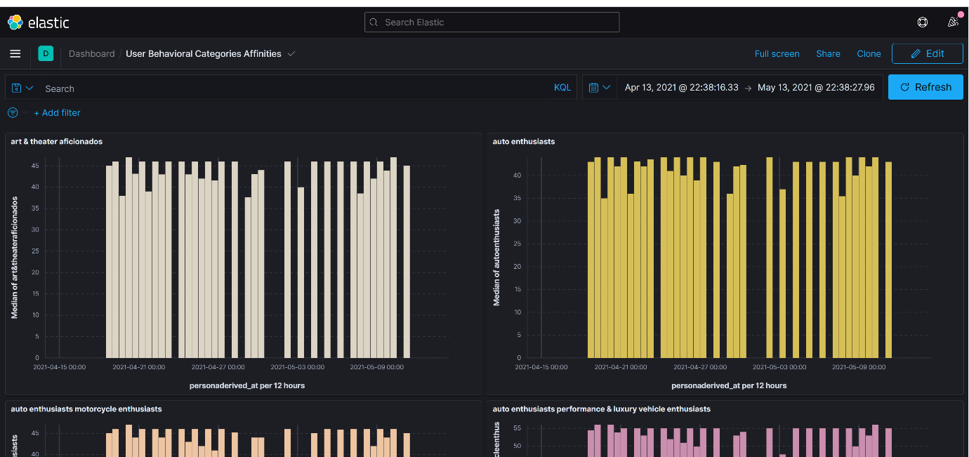

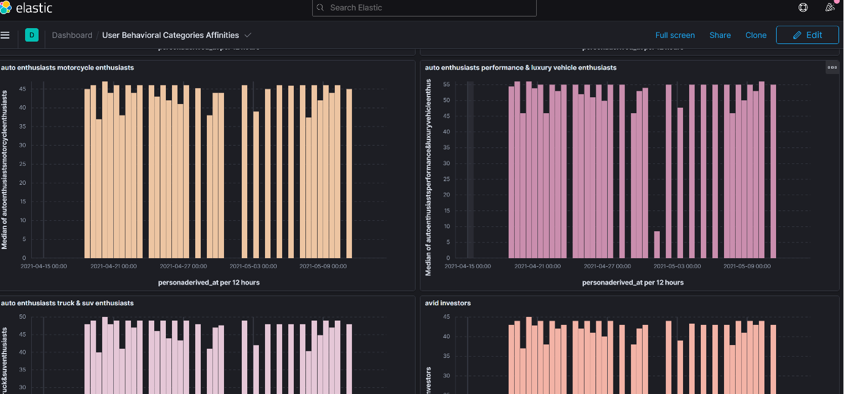

**(People had high affinity score towards luxury vehicles (Might be because too much indoor activity)**

**(People naturally feel more outdoorsy and read related content)**

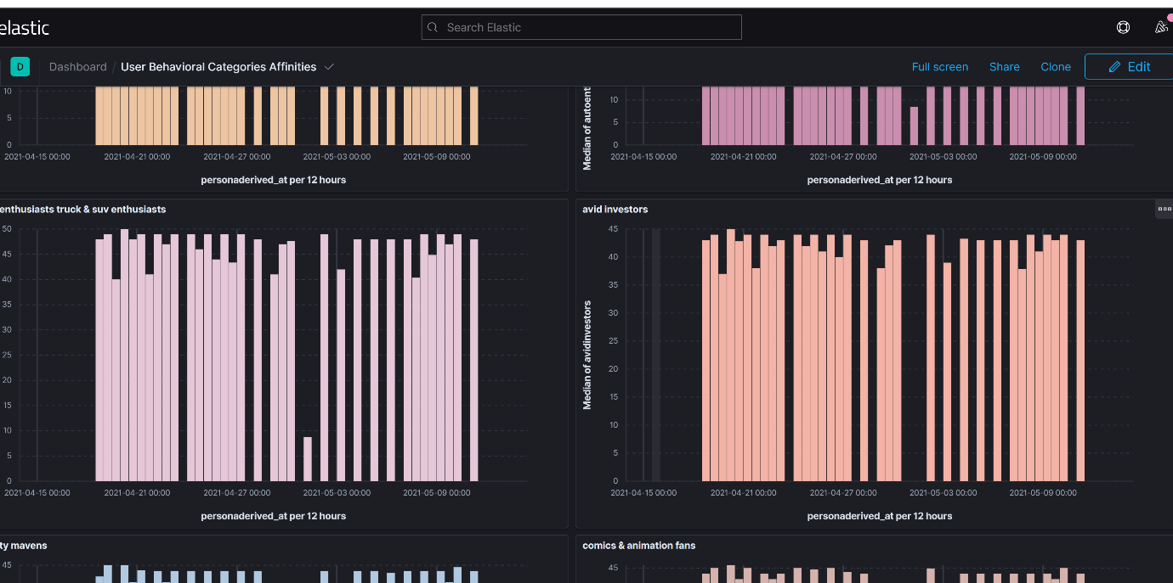

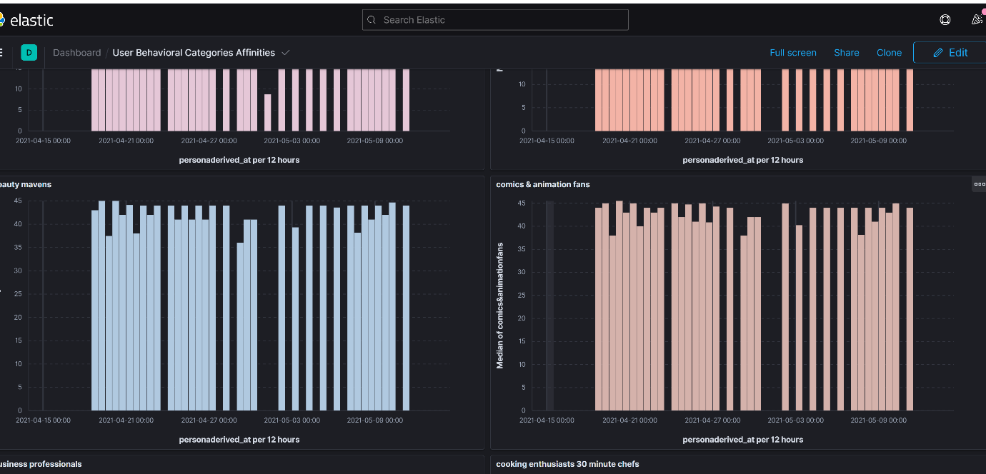

(Interest in Cooking increased during this period)

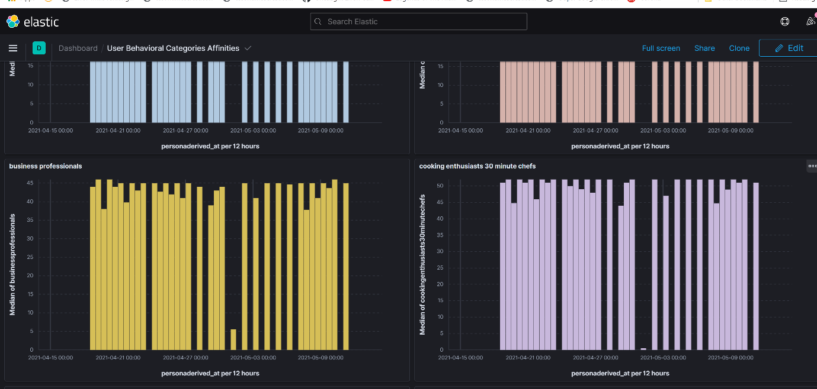

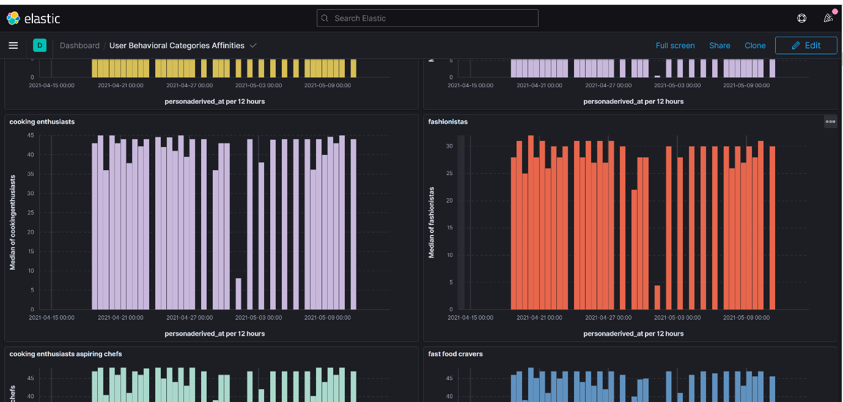

(Interest in fashion decreased during covid 19 pandemic second wave due to overall negative emotion as derived from emotion persona reports)

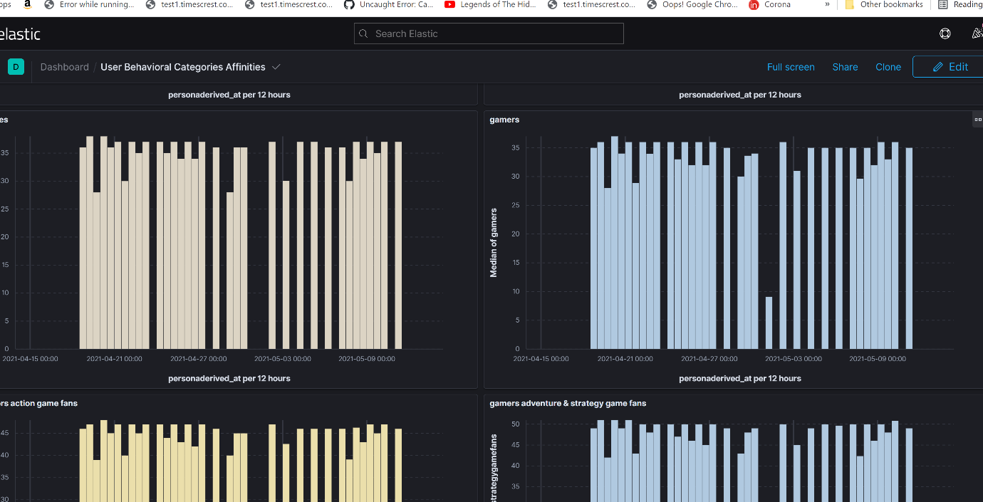

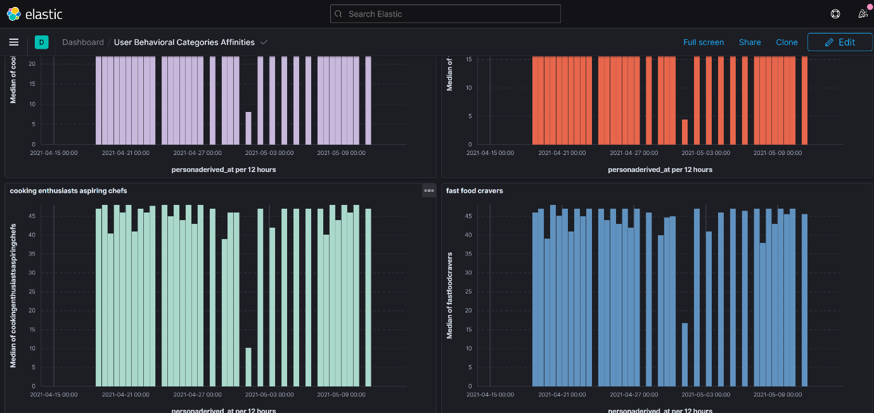

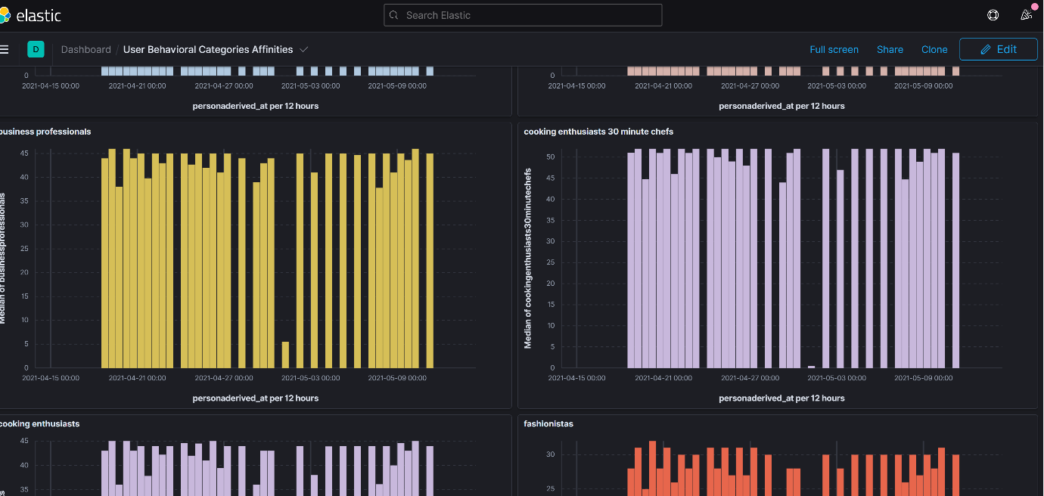

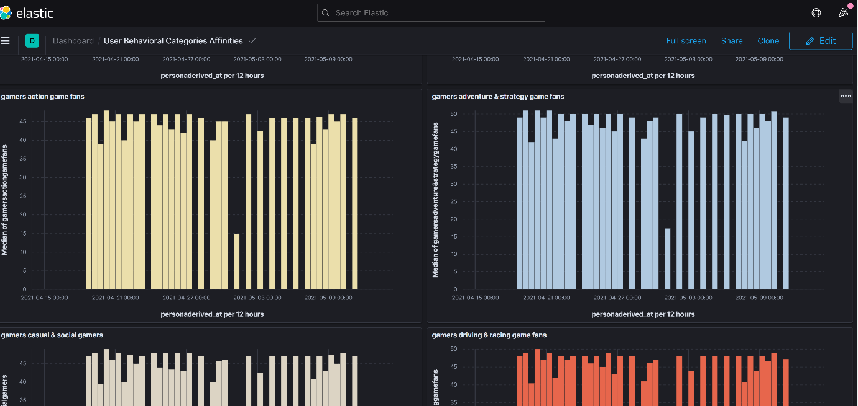

(Adventure, Racing, Sports Genre based Games got high interest during second wave of pandemic)

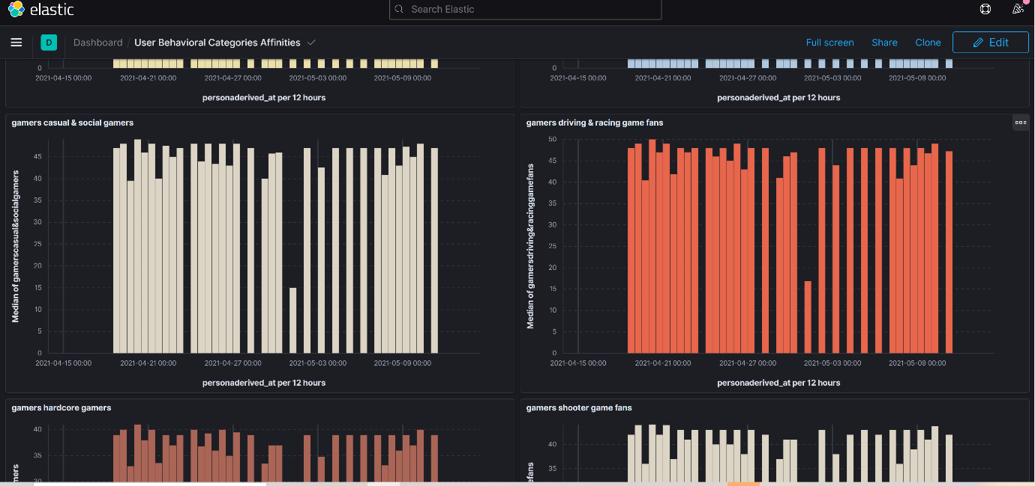

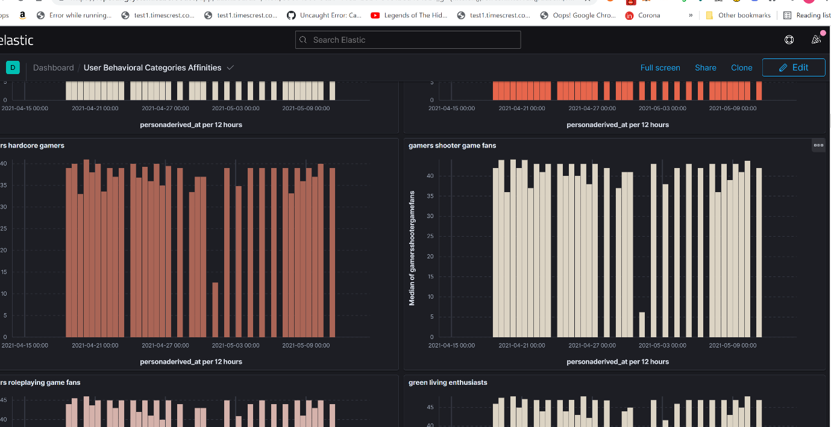

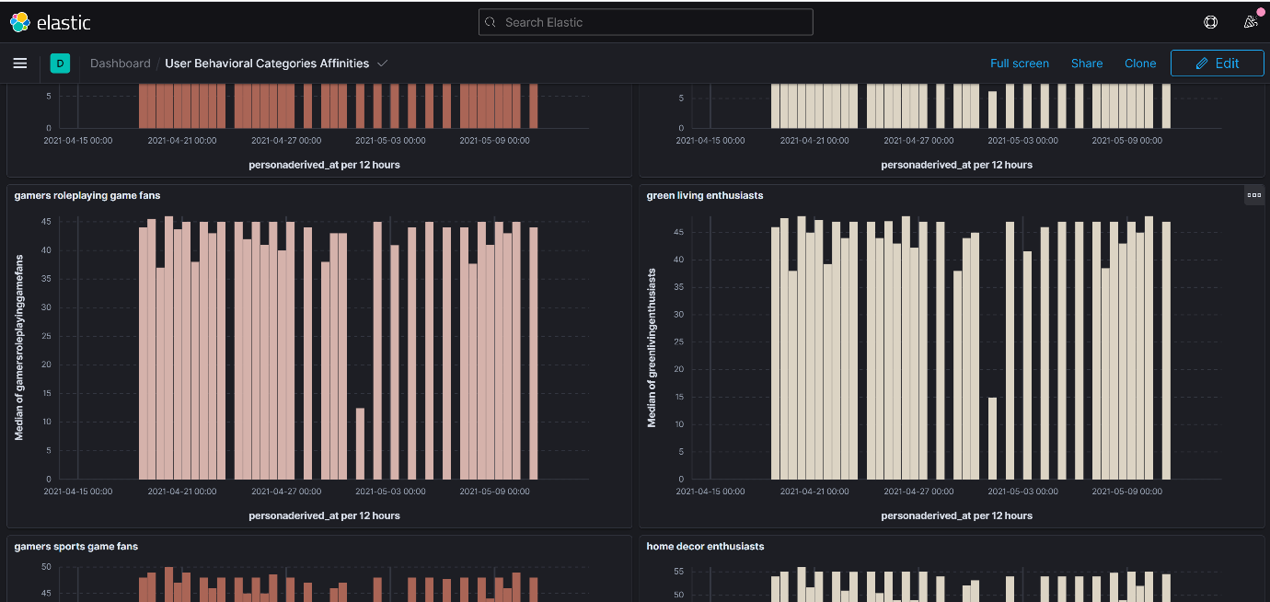

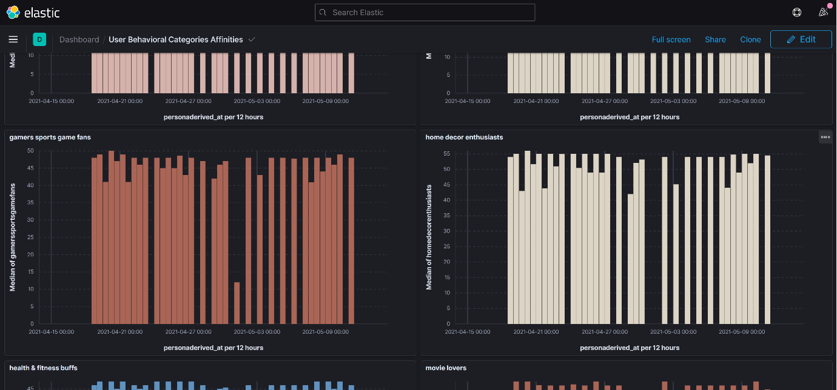

(home Decoration and interiors got high interest during covid 19 pandemic second wave)

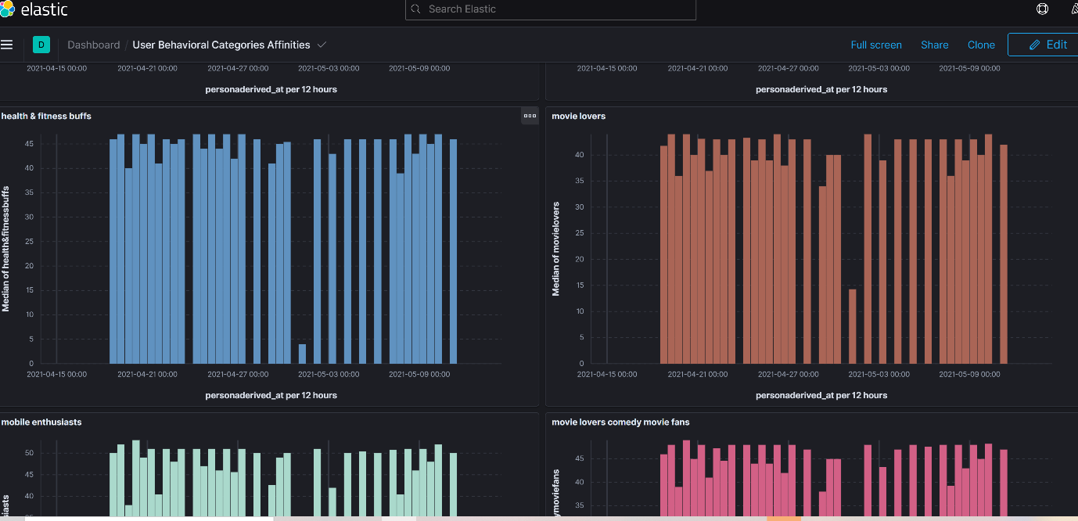

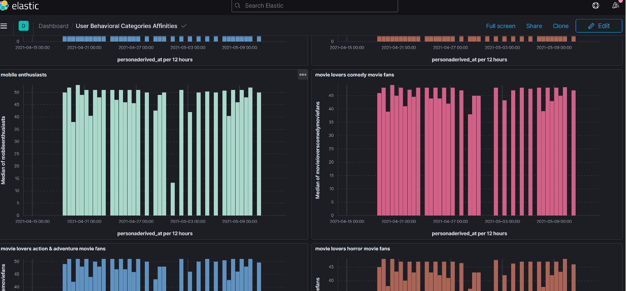

(Logically smart phone interest was also high)

(Dominating Movie Genres – family movies which is pretty obvious)

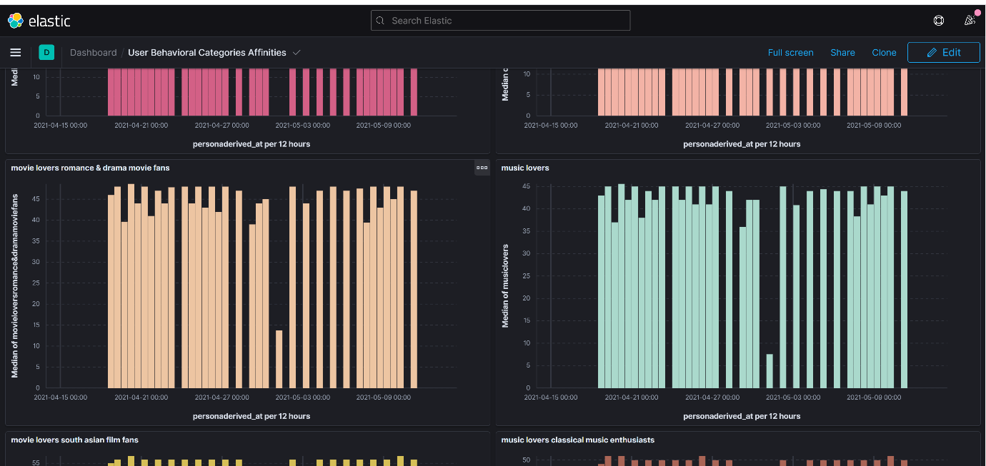

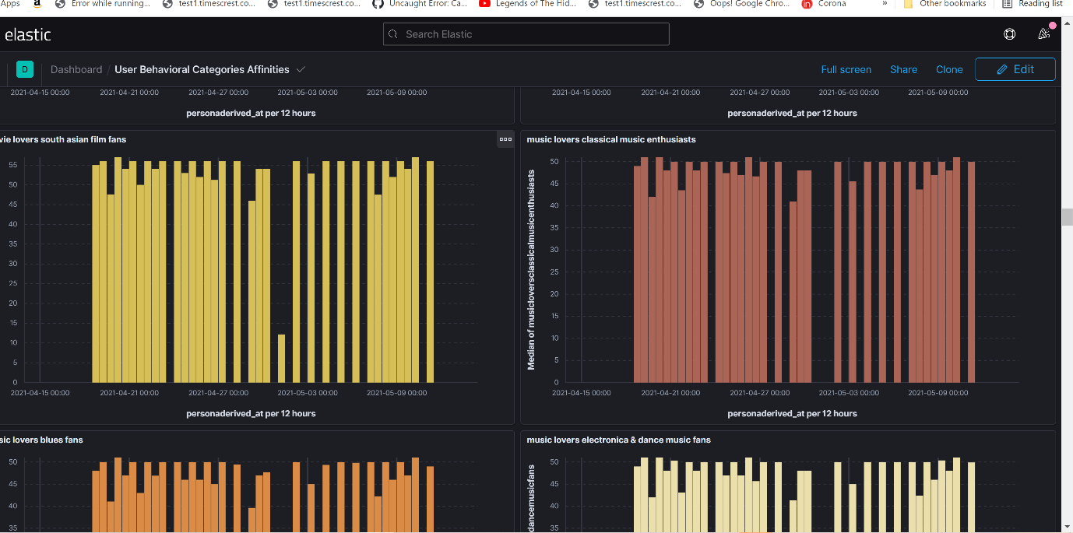

(Dominating Music Genre – Classical Music, Electronics/Dance music, Blues, Country ,Jazz, Pop, folk and traditional music)

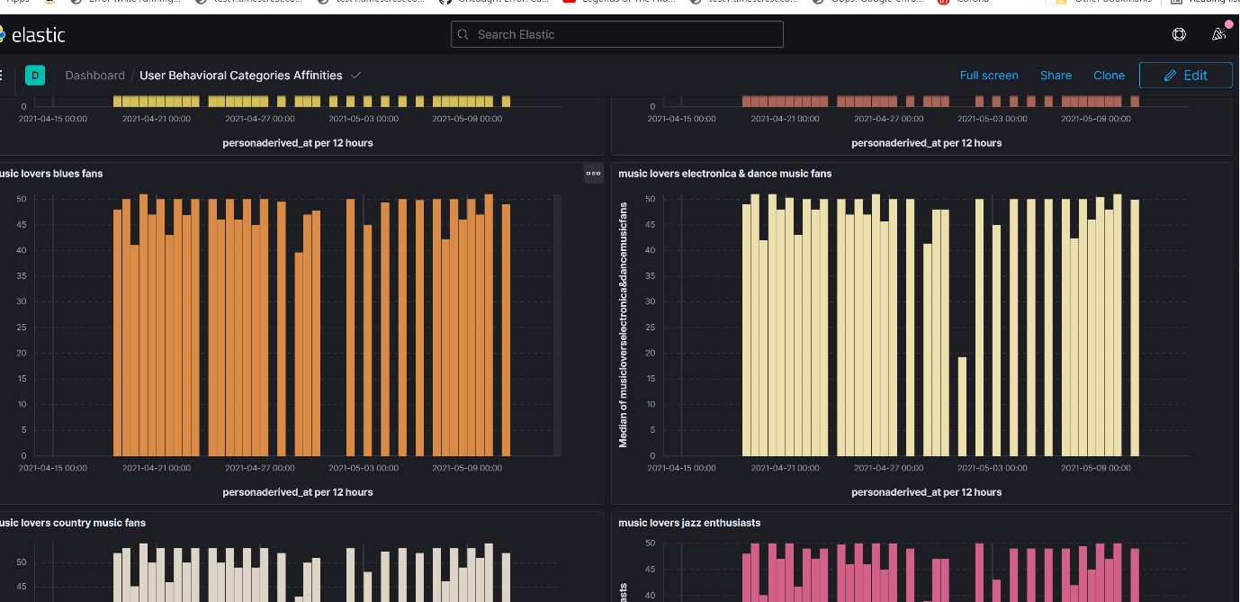

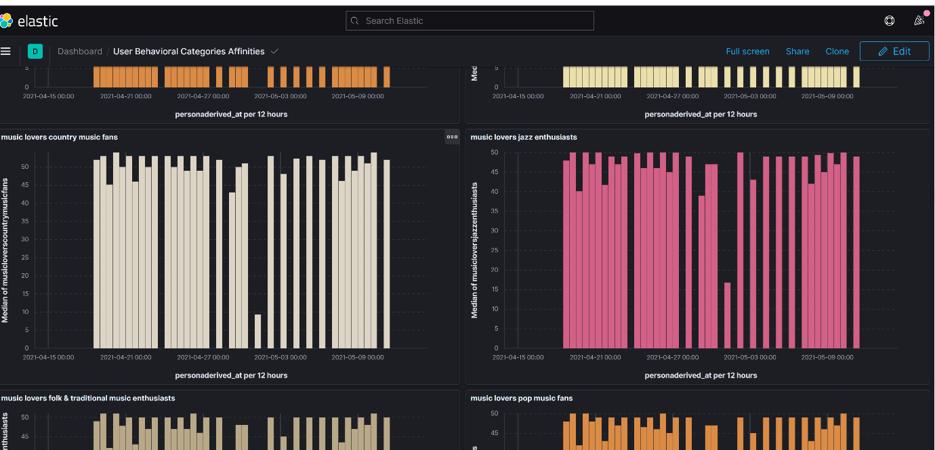

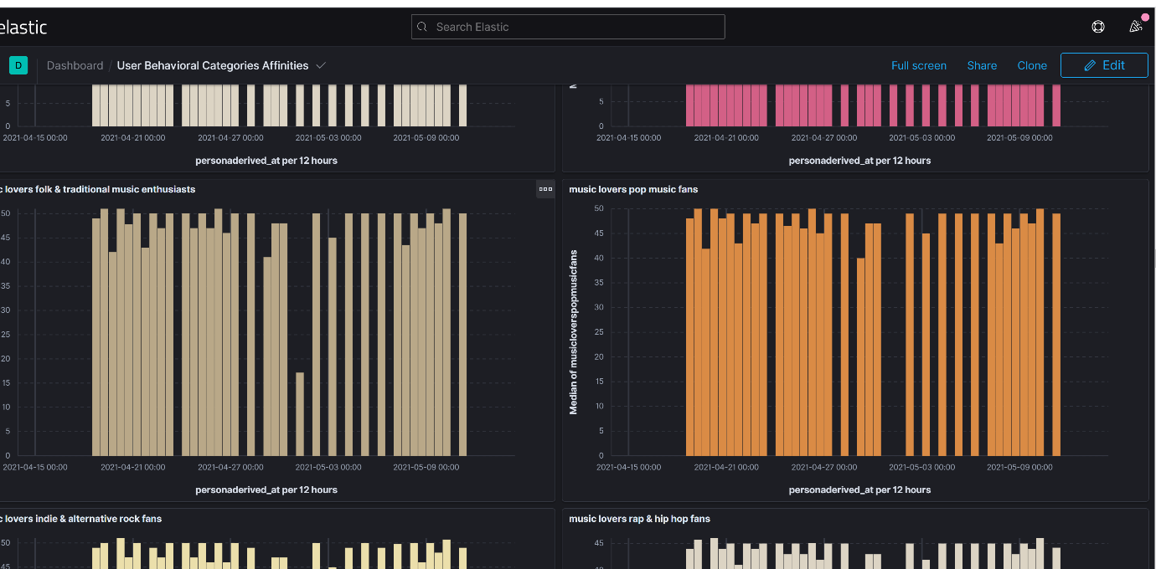

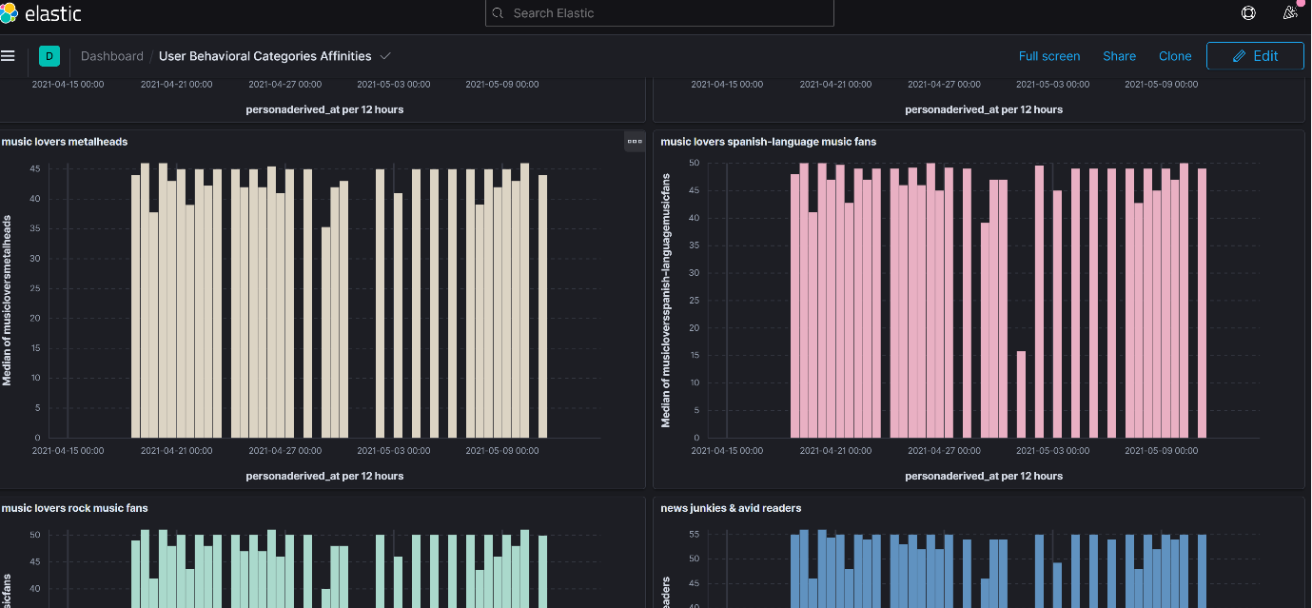

(Interest in heavy metal was relatively low)

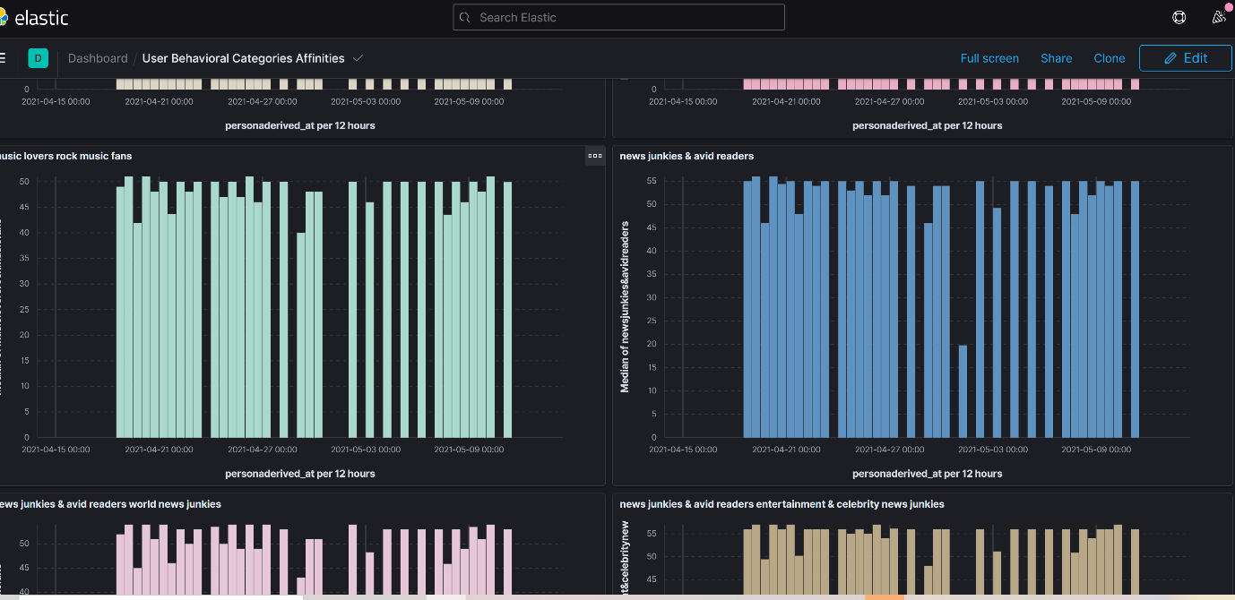

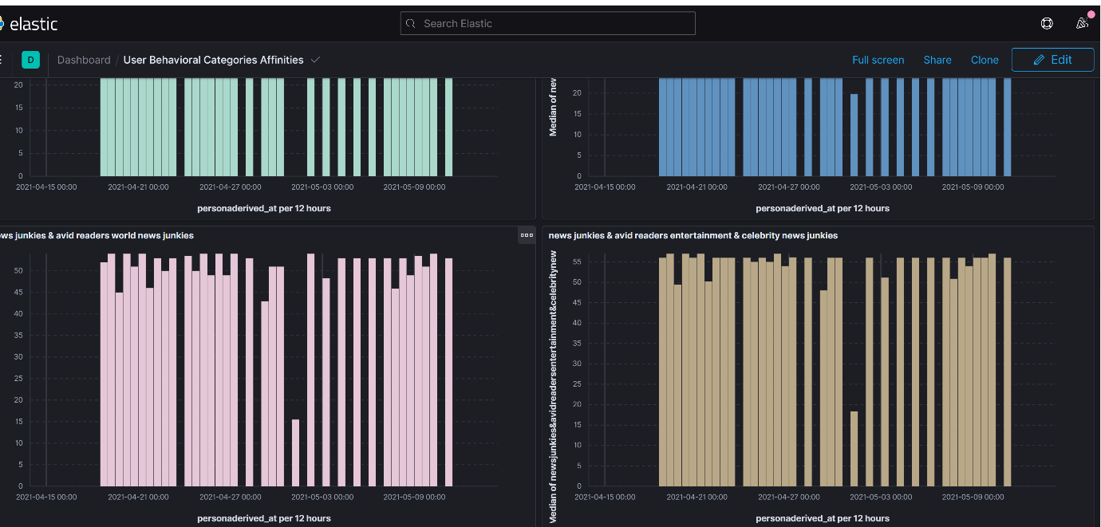

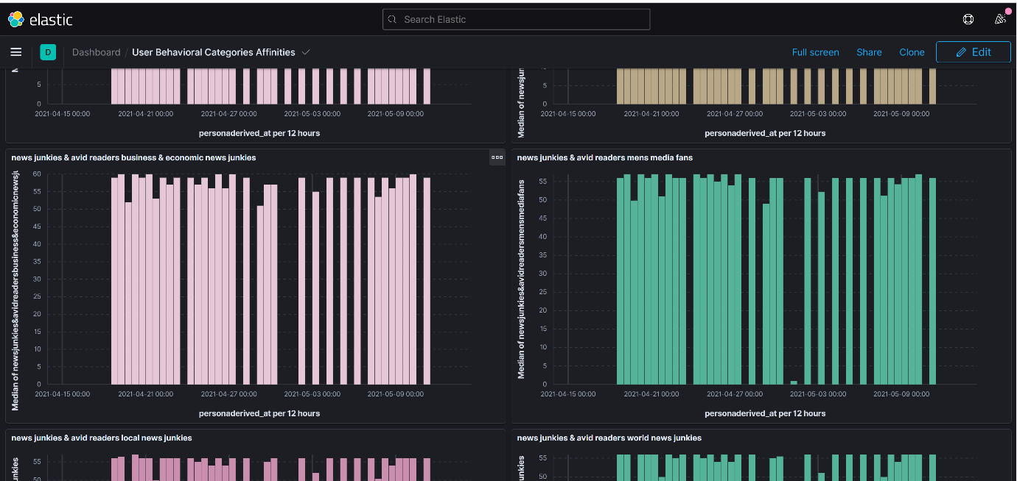

(Among news cateogries – local, world, business, economic news junkie, entertainment and celebrity news)

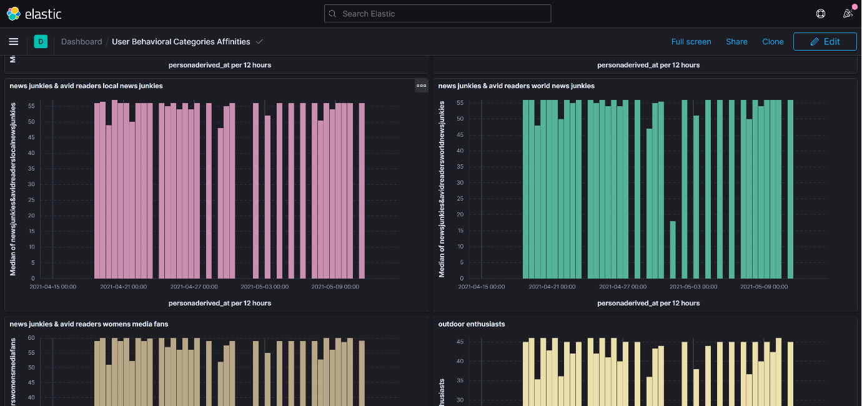

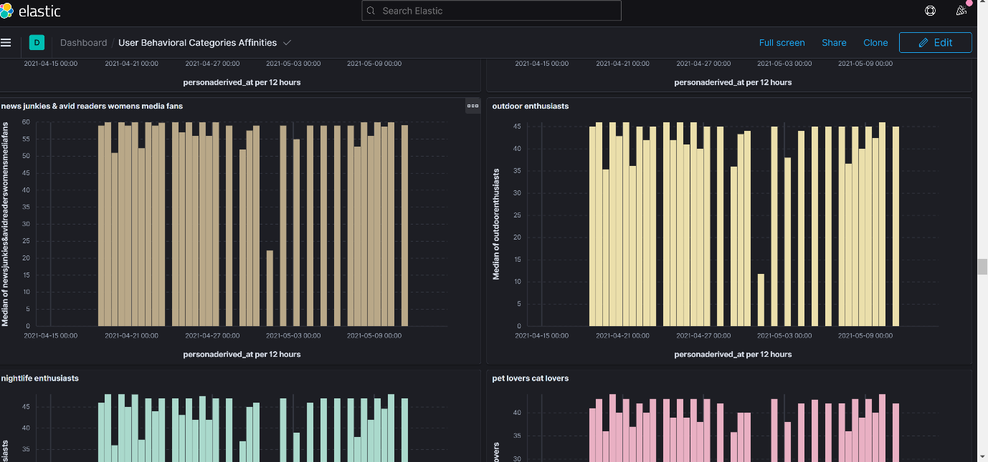

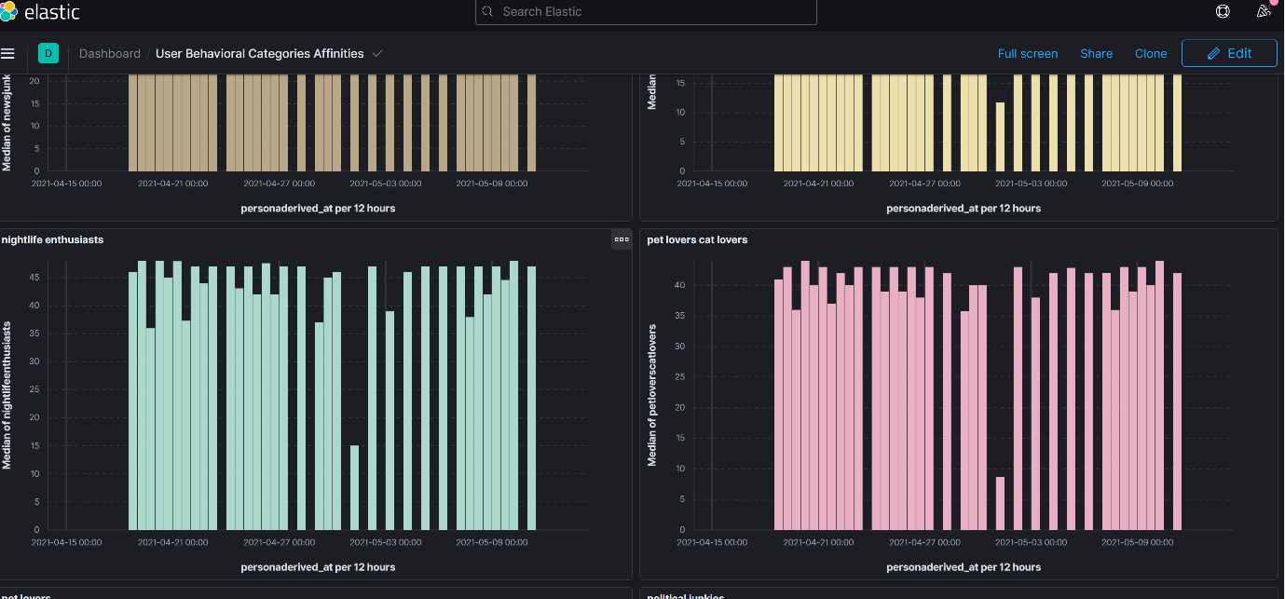

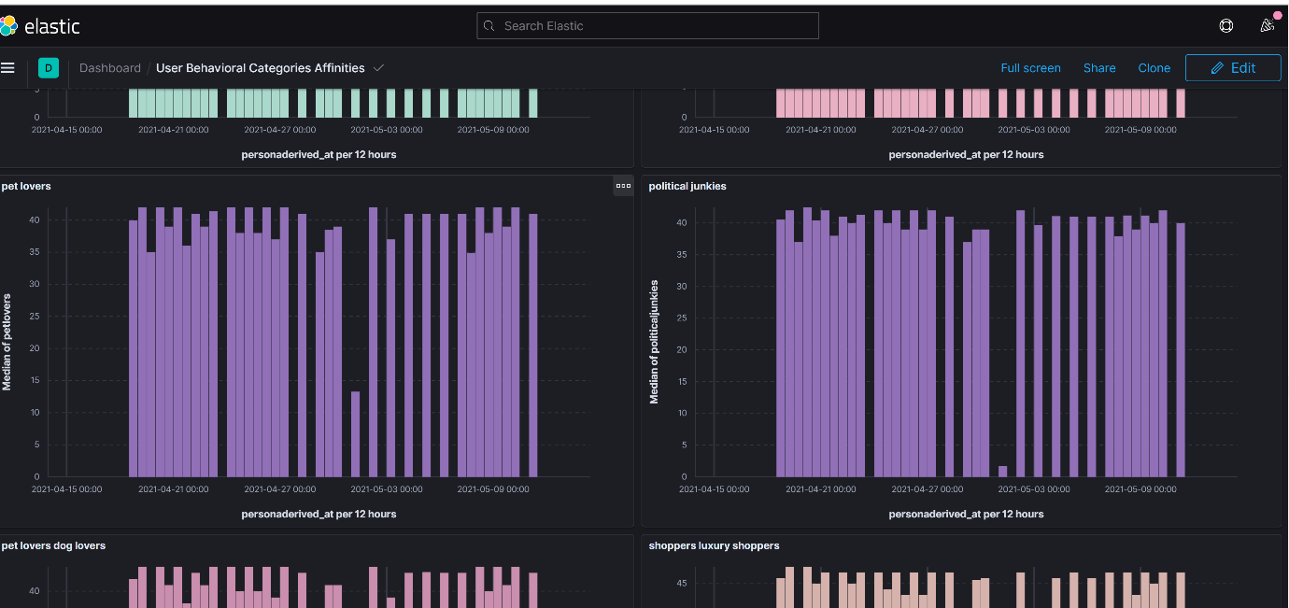

(Interest in pets was relatively low)

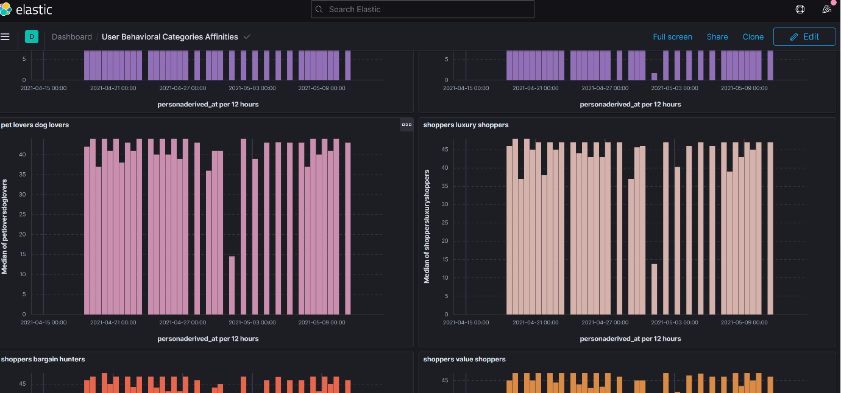

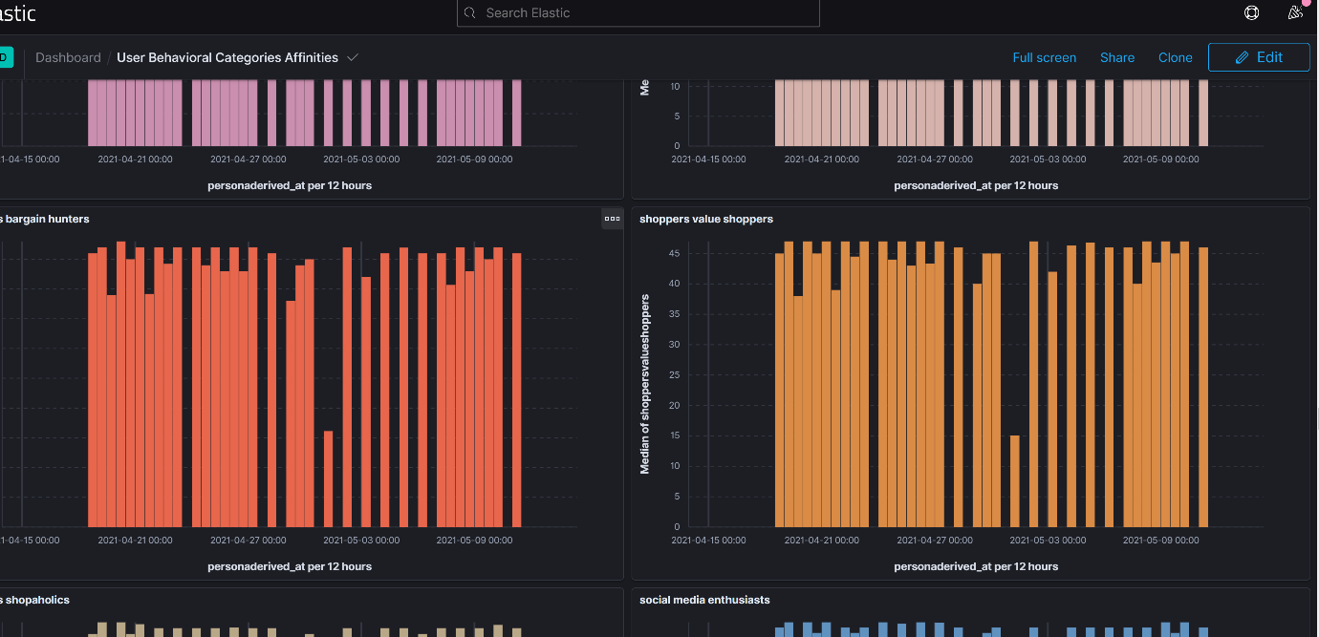

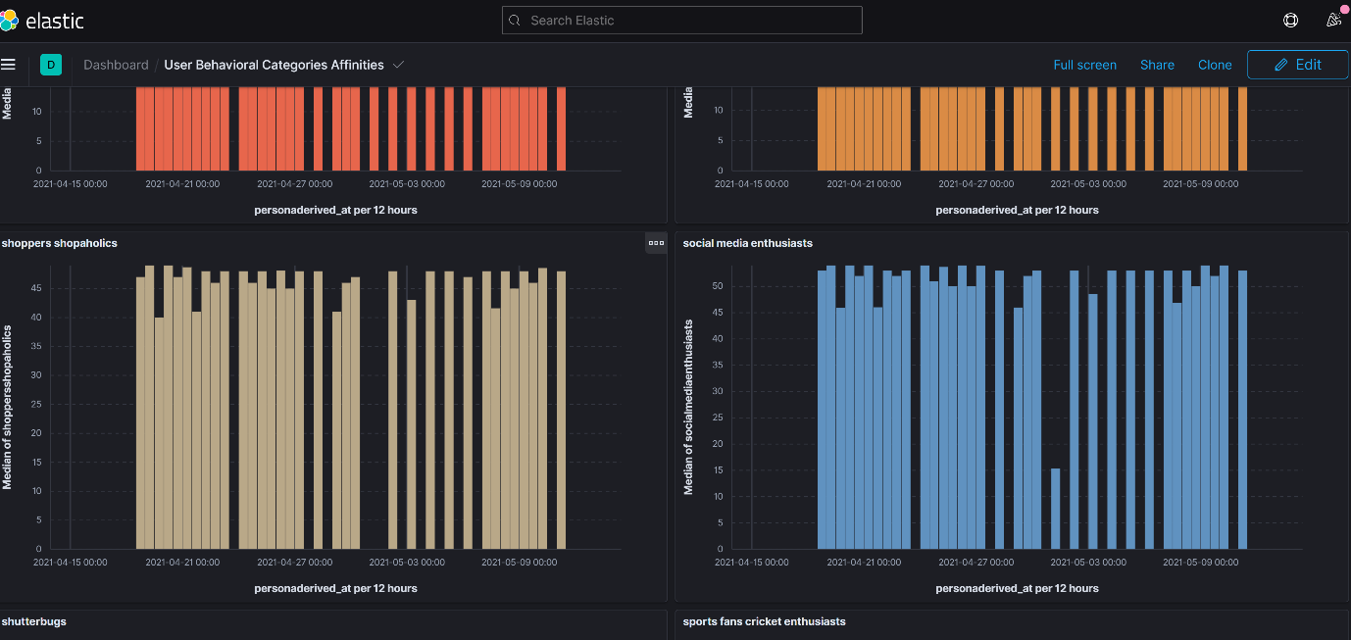

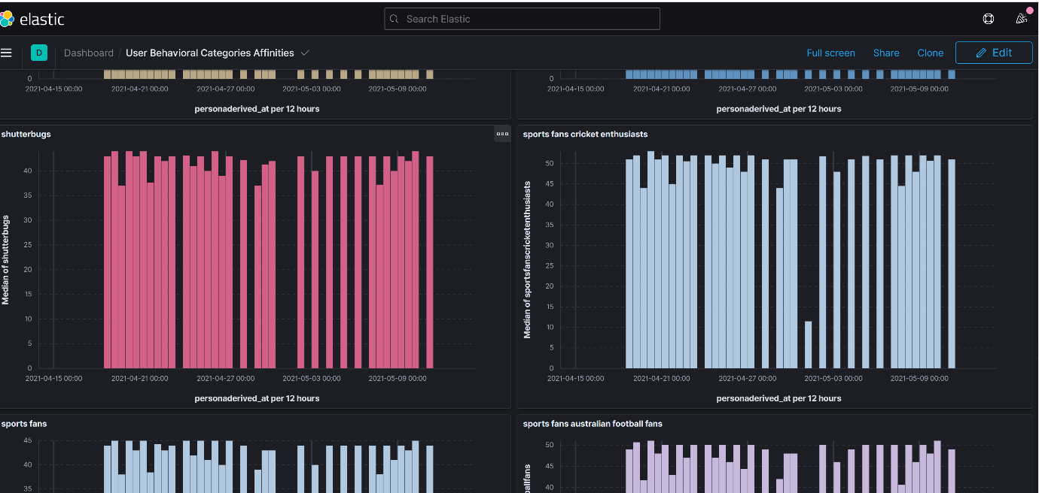

(Among sports category – dominant sports included - (cricket due to ipl (which got suspended in early May)

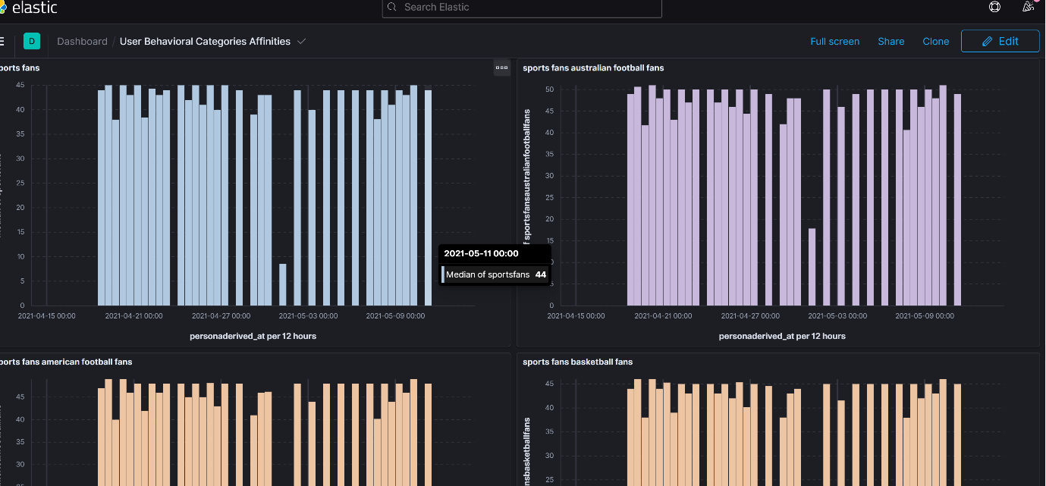

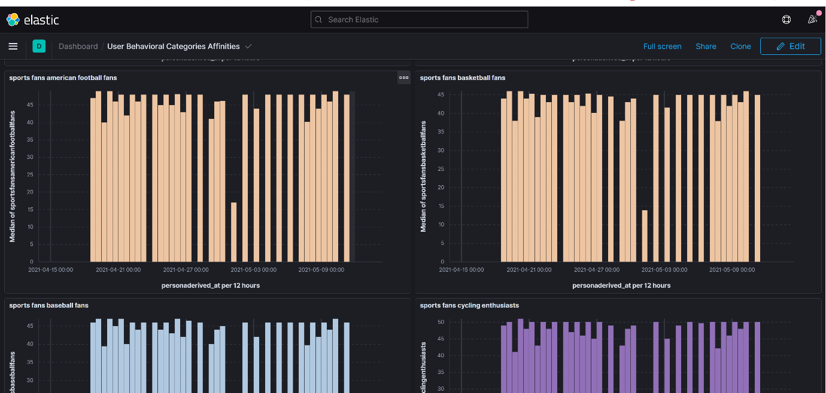

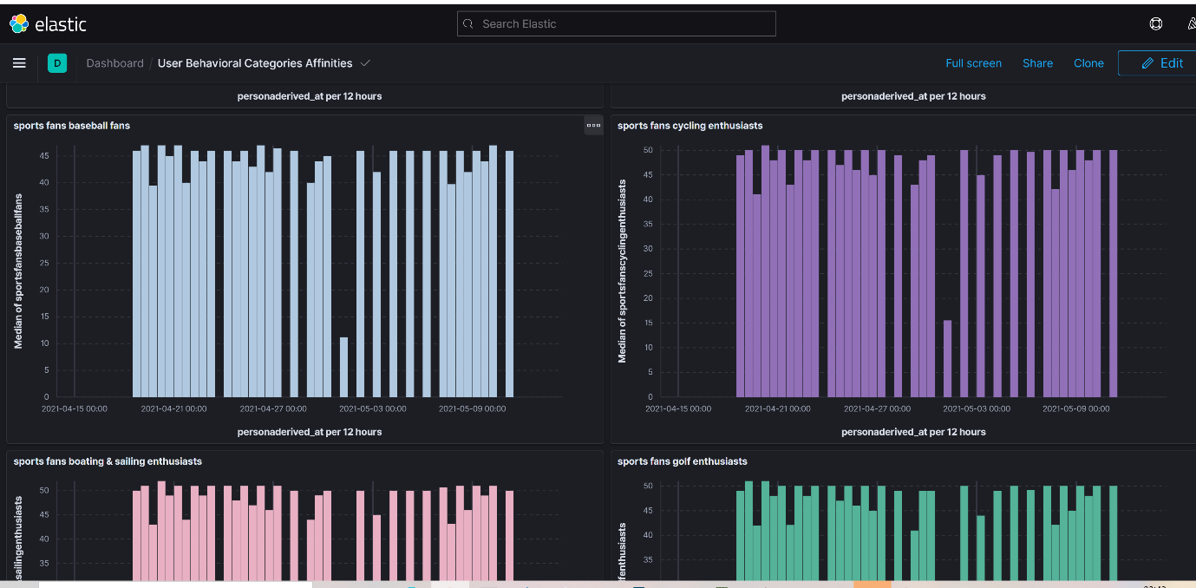

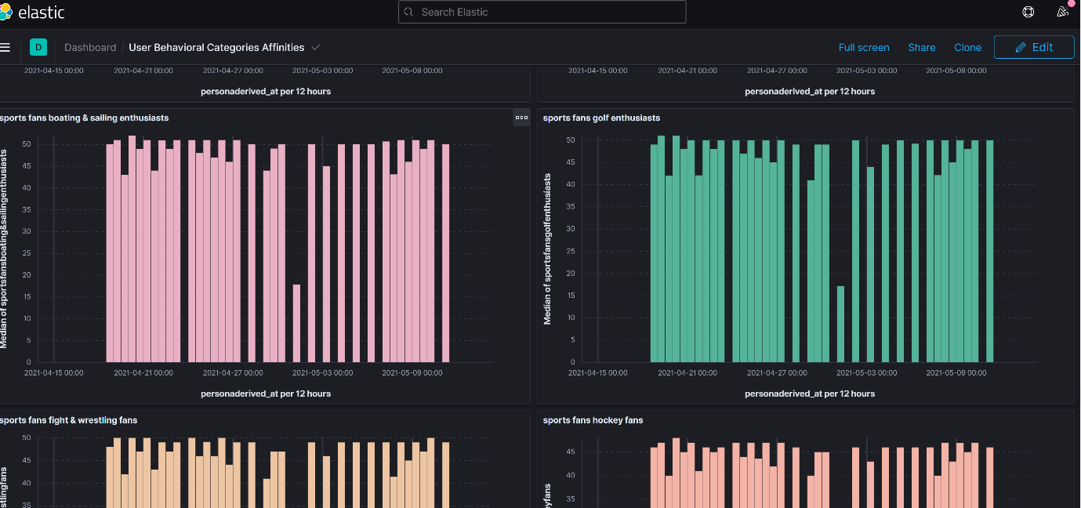

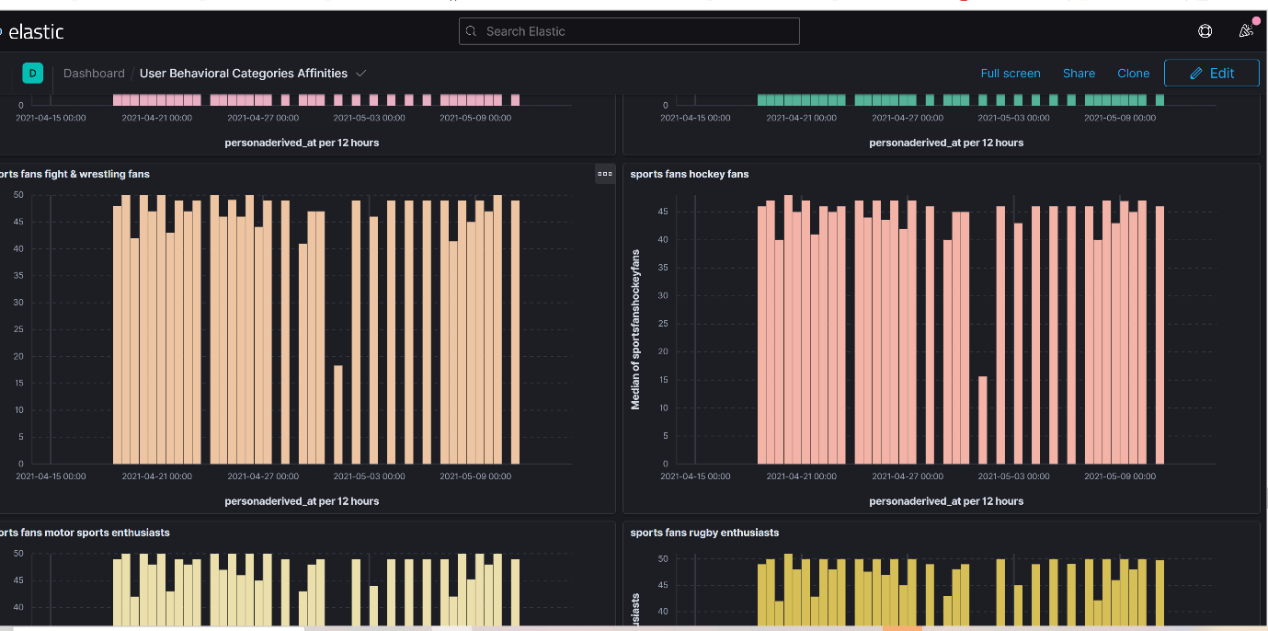

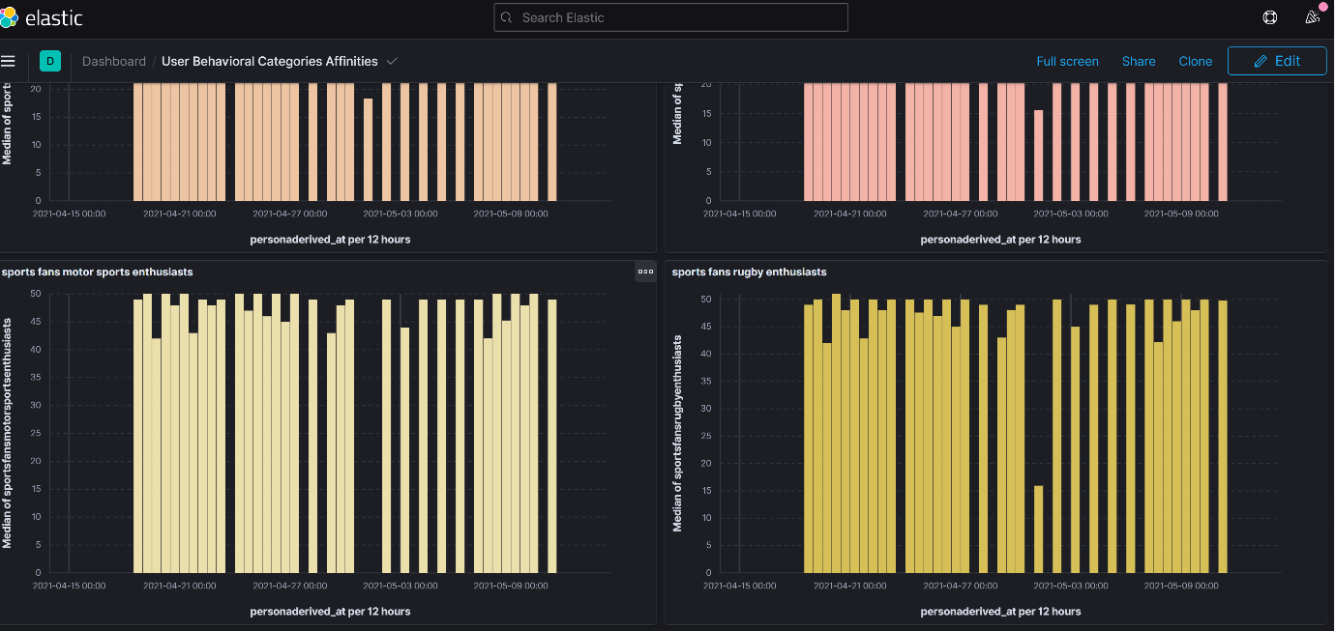

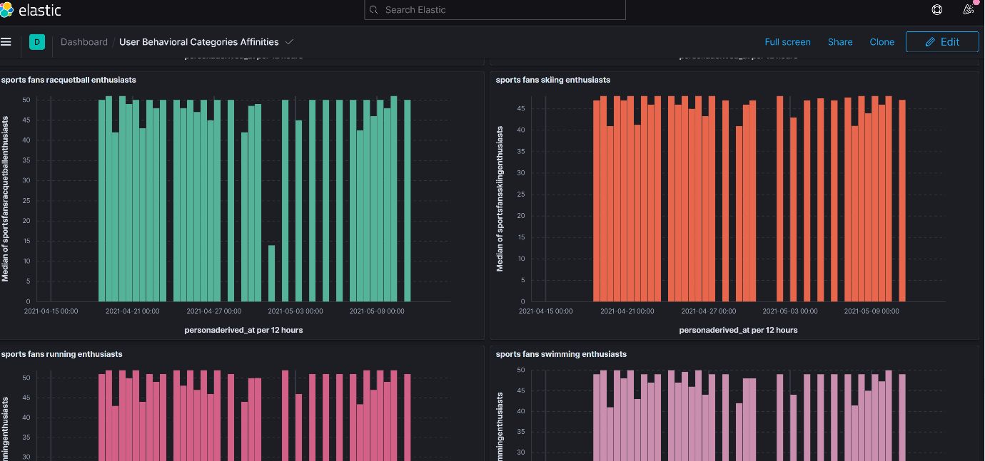

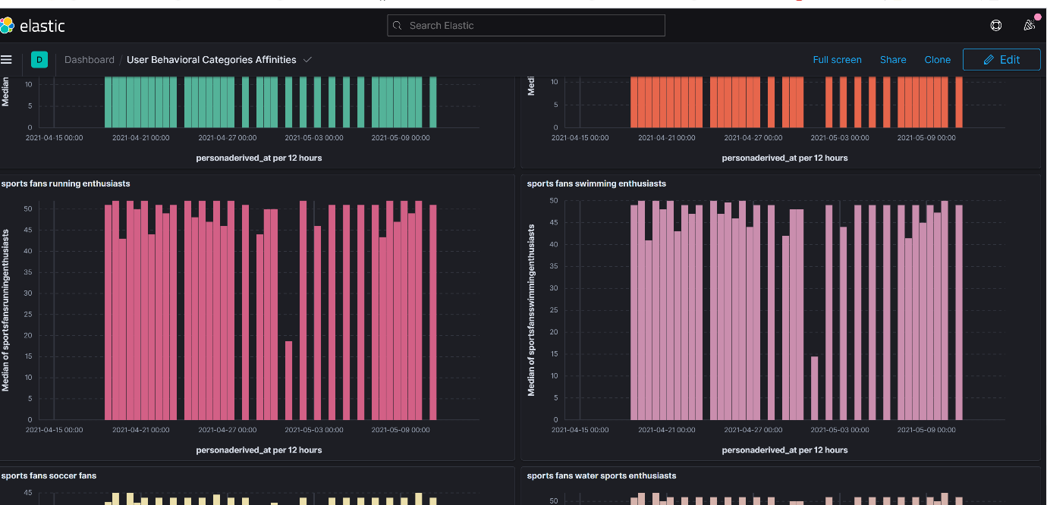

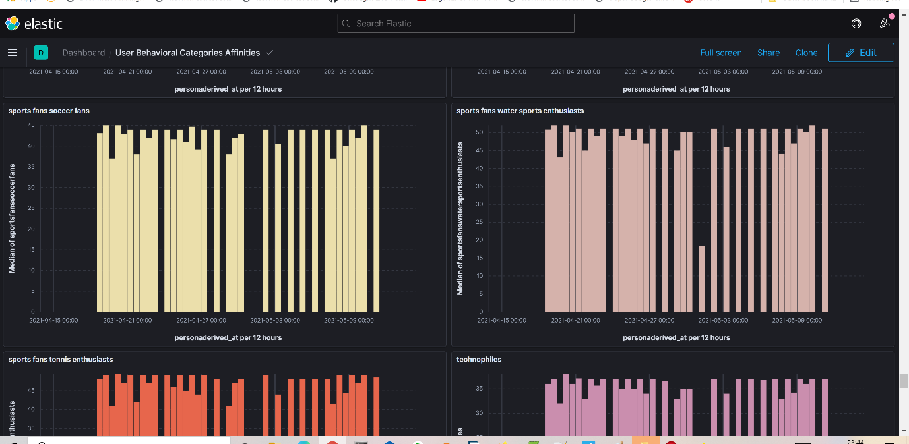

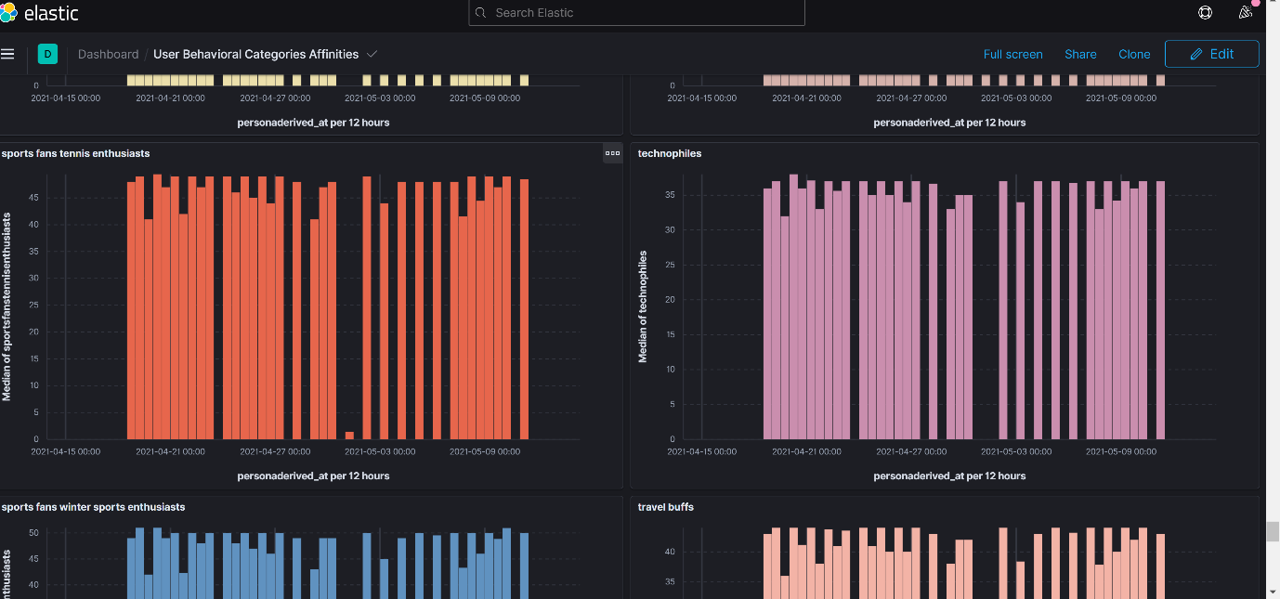

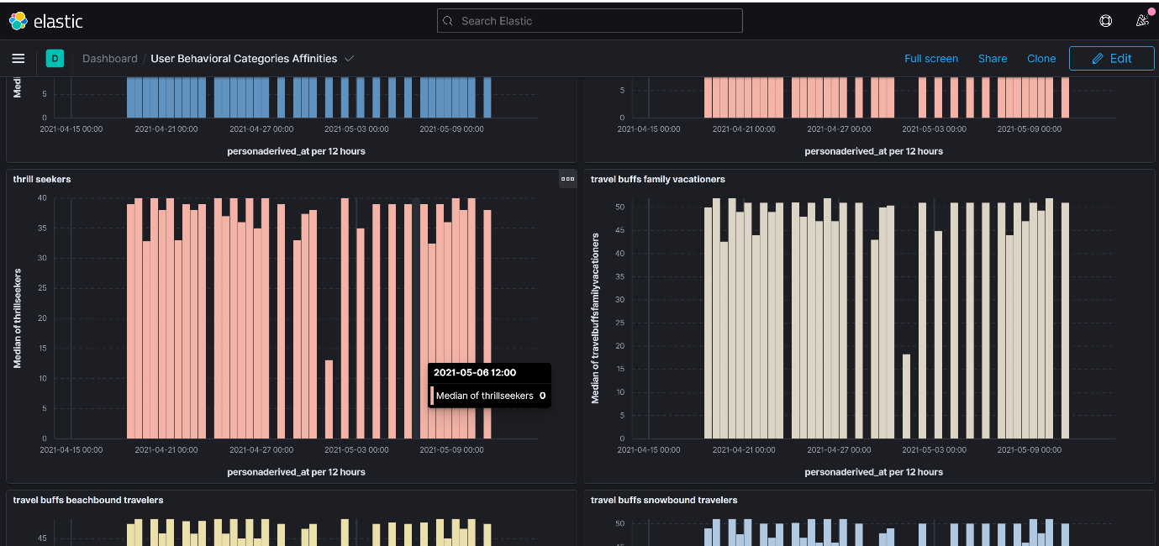

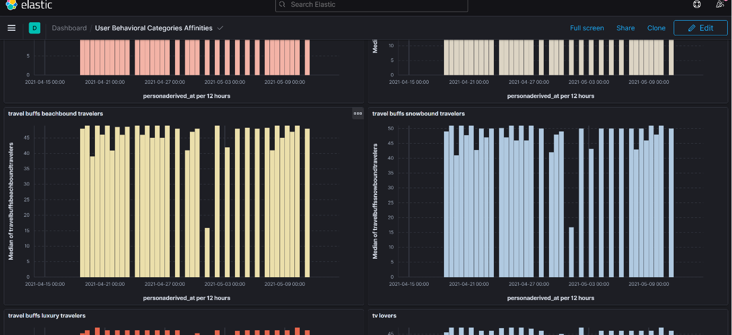

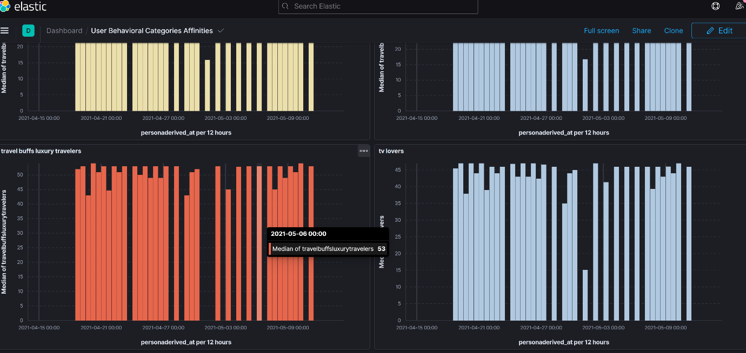

Category Graphs can be filtered by different data points.

1)Top Category section wise

2)Top Category IAB segment wise

3)Top Category topic wise

4)Top Category geography (city/state wise)

5)Top Category by loyalty type

6)Top Category by website – Aajtak/Indiatoday

**(Publisher Segment Analysis)**

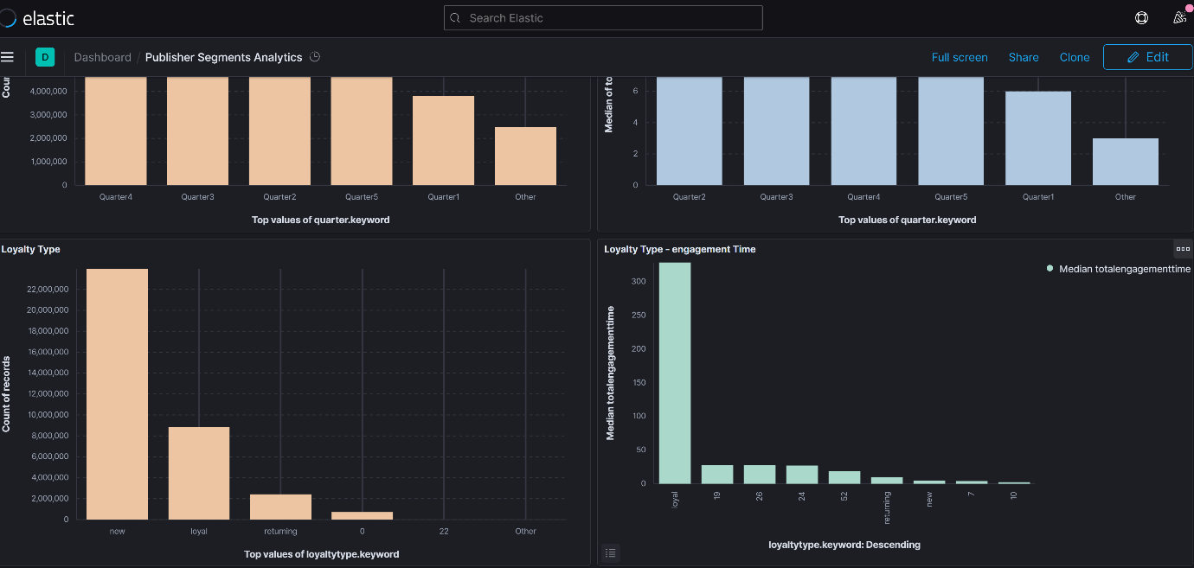

**(As it can be seen from static pattern – loyal users have high engagement time)**

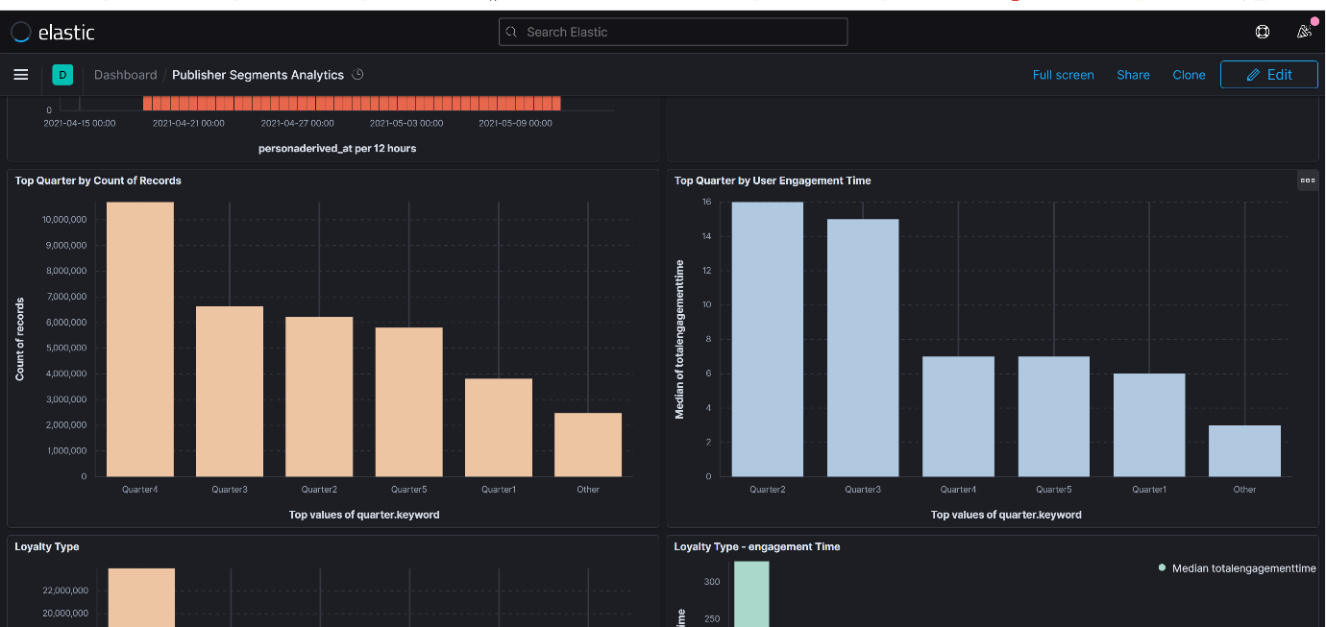

**(Top Quarters during COVID 19 pandemic second wave – Quarter 4 (12 - 4), Quarter 3 (8 - 12) , Quarter 2 ( 4 - 8) was dominant)**

**Top Quarter by user engagement time**

**(As It can be seen morning period – Quarter 2/Quarter 3 were high engagement quarters during COVID 19 pandemic)**

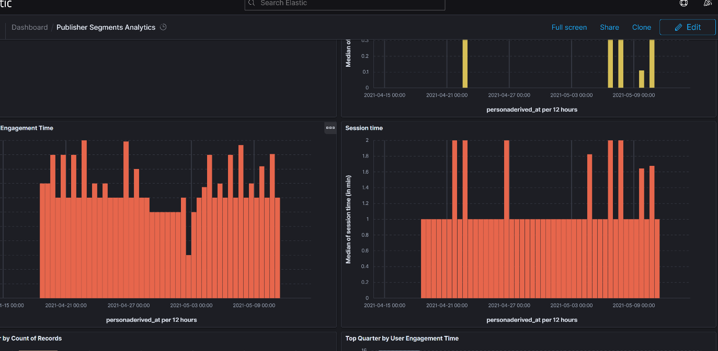

**(Engagement Time of Users (In minutes) trend)**

**(Session Time of Users (In minutes) trend)**

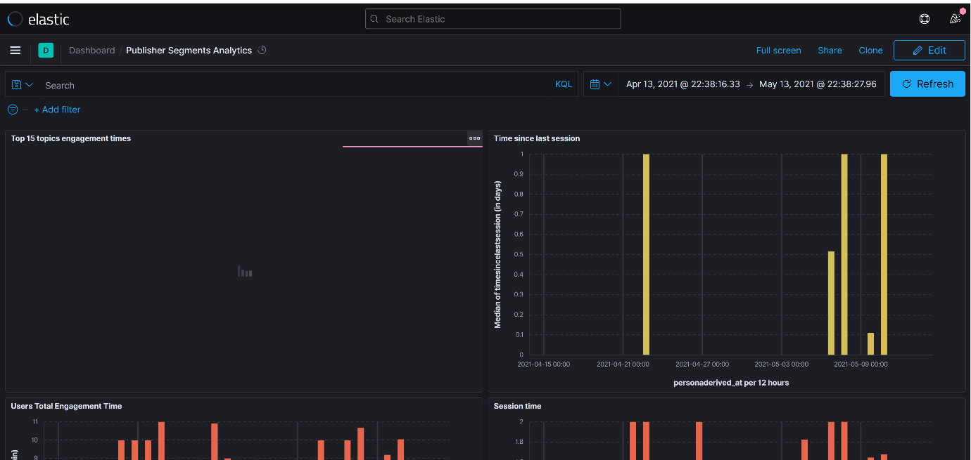

**Publisher Segment Graphs can be filtered by different data points.**

**1)Top Publisher Segments section wise**

**2)Top Publisher Segments IAB segment wise**

**3)Top Publisher Segments topic wise**

**4)Top Publisher Segments geography (city/state wise)**

**5)Top Publisher Segments by loyalty type**

**6)Top Publisher Segments by website – Aajtak/Indiatoday**

Emotion Persona Reports

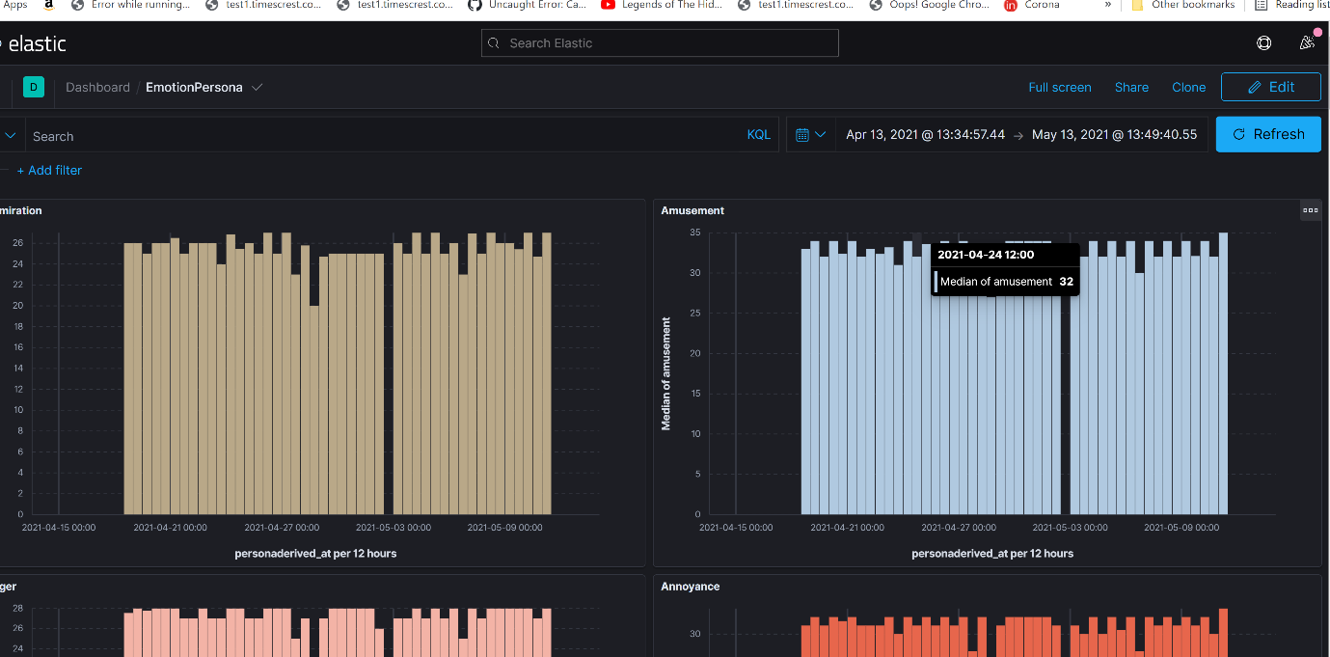

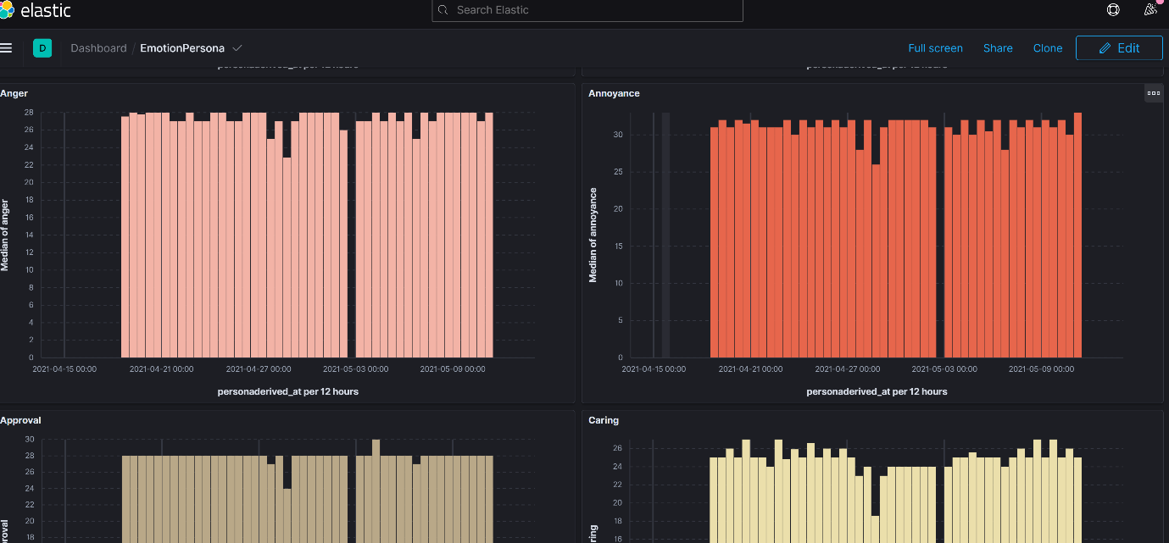

1)Annoyance emotion level was also high during covid 19 second wave.

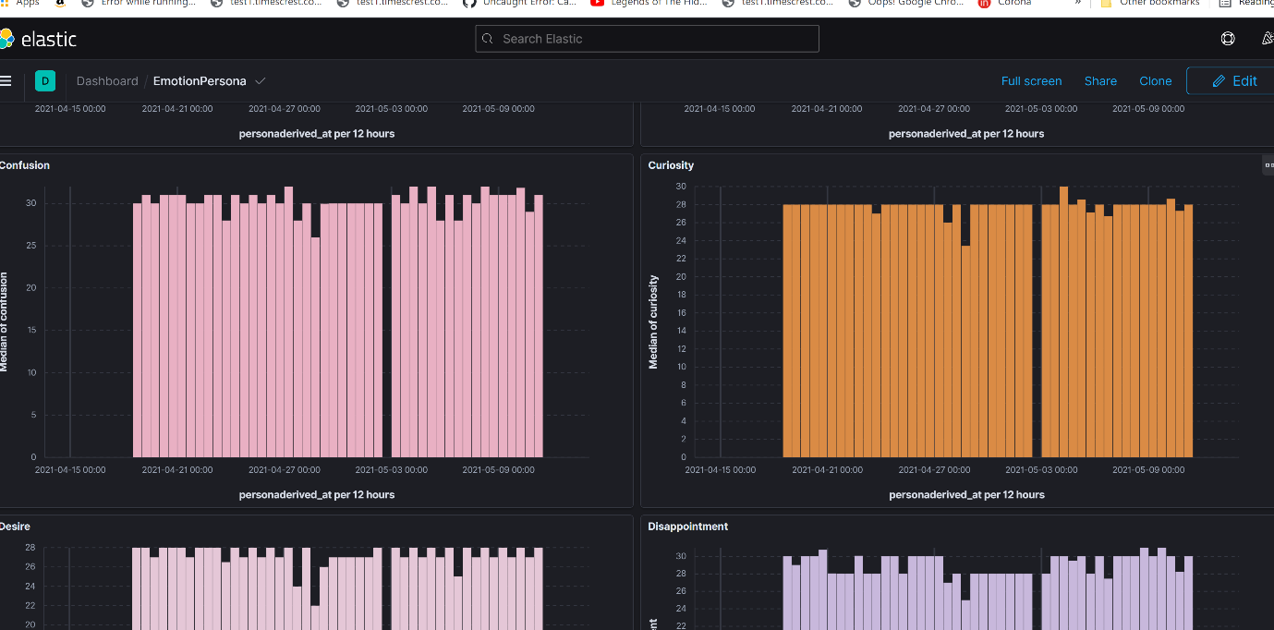

2)Curiosity levels were high during covid 19 second wave

3)Confusion levels were high during covid 19 second wave

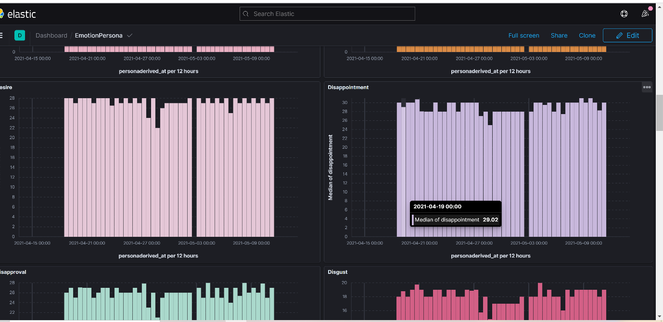

4)Disappointment levels were high during covid 19 second wave

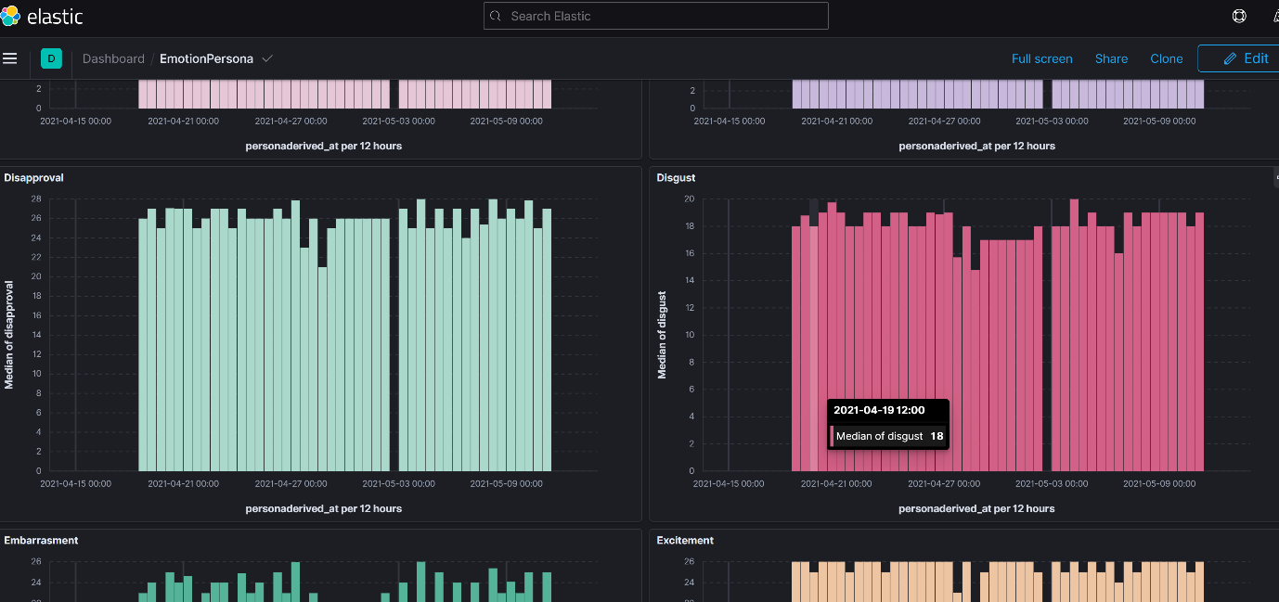

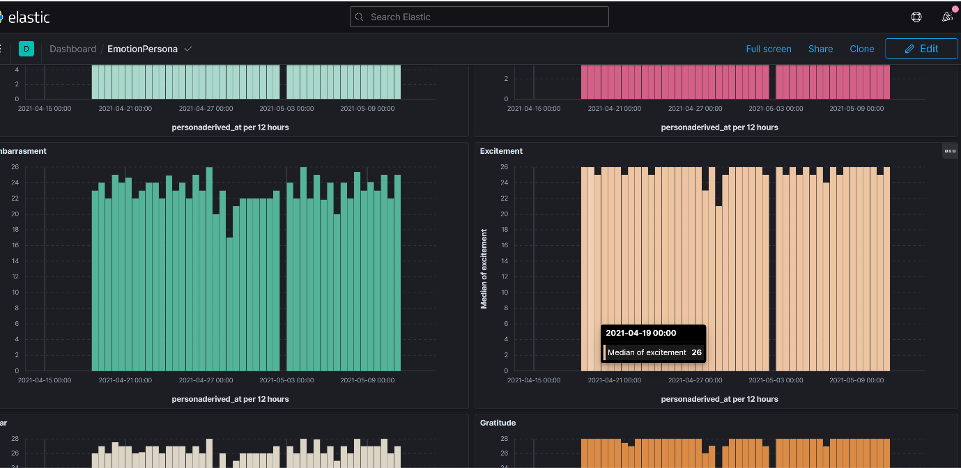

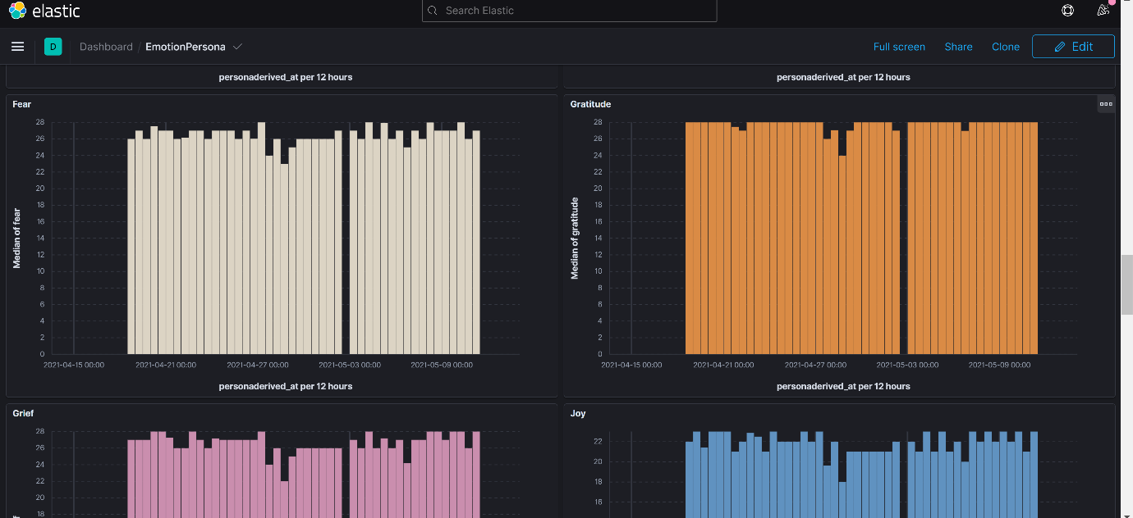

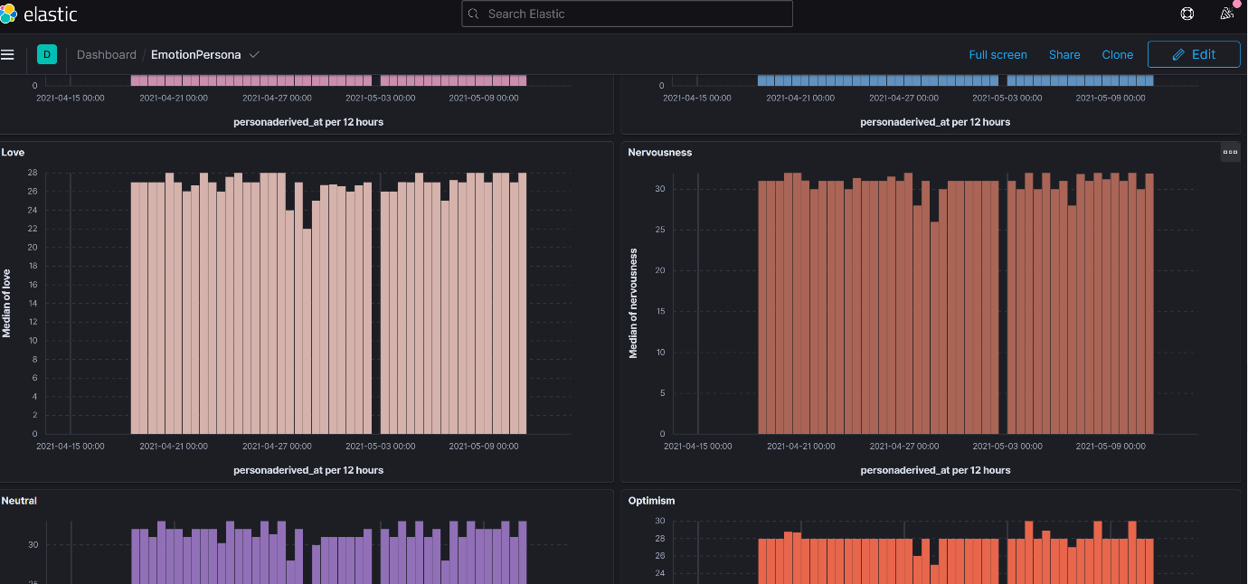

5)Nervousness levels were high during covid 19 second wave.

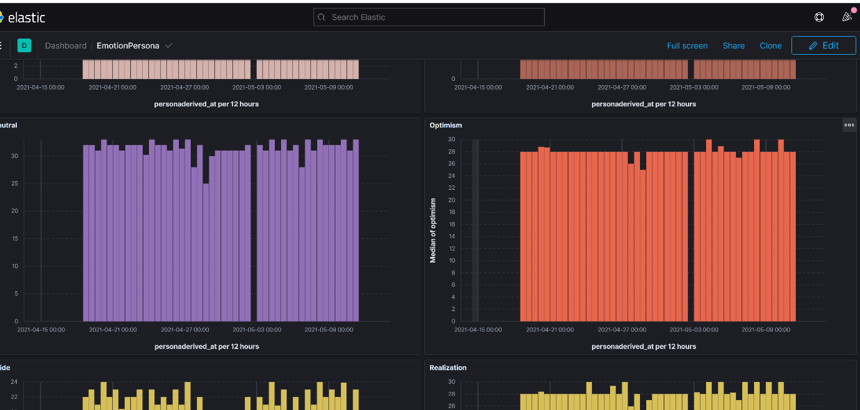

6)Neutral and Optimism levels were high during COVID 19 second wave.

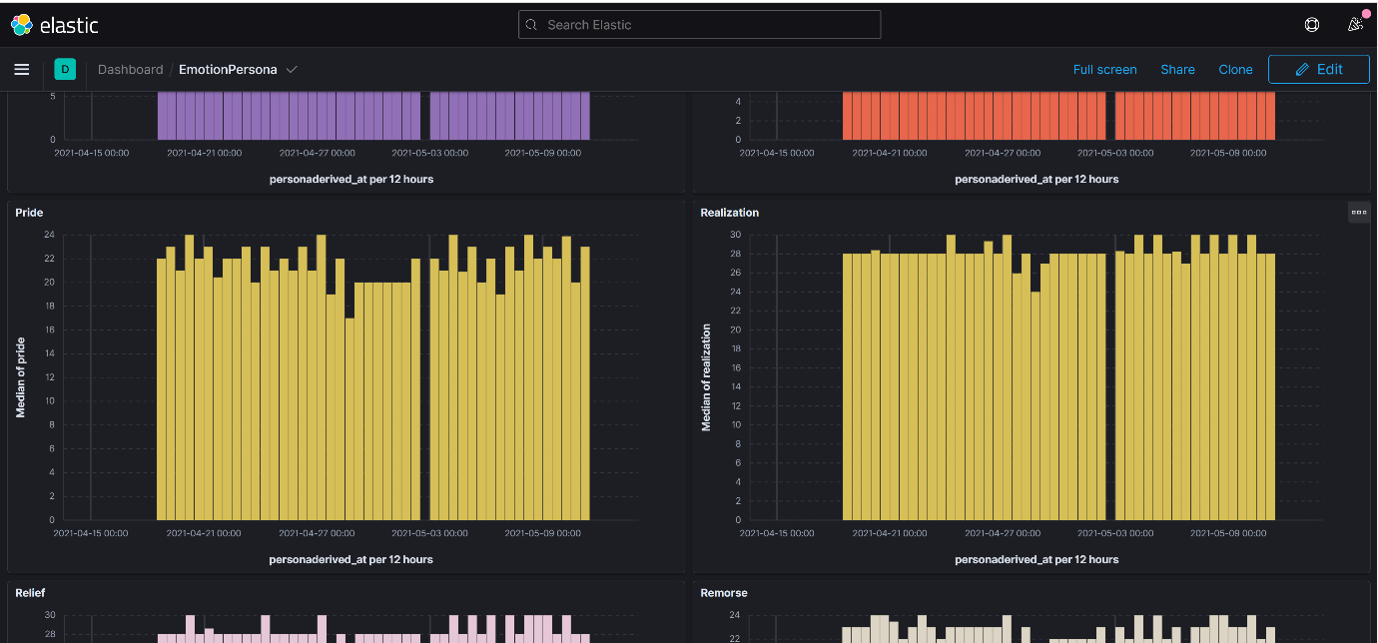

7)Realization levels were high during COVID 19 second wave.

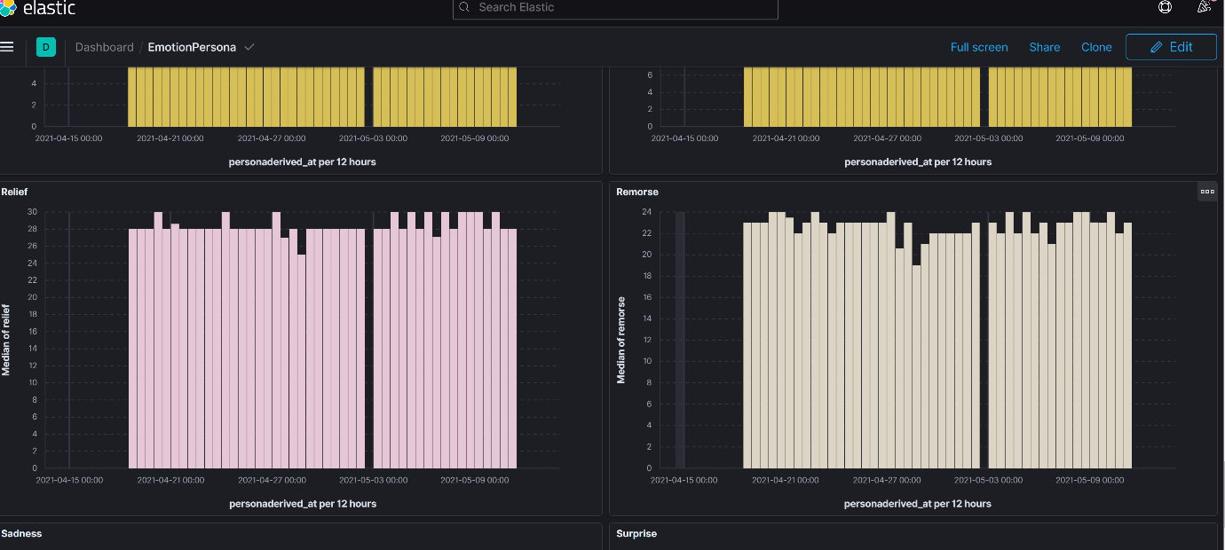

8)Relief emotion level was high during covid 19 second wave when the second wave went down.

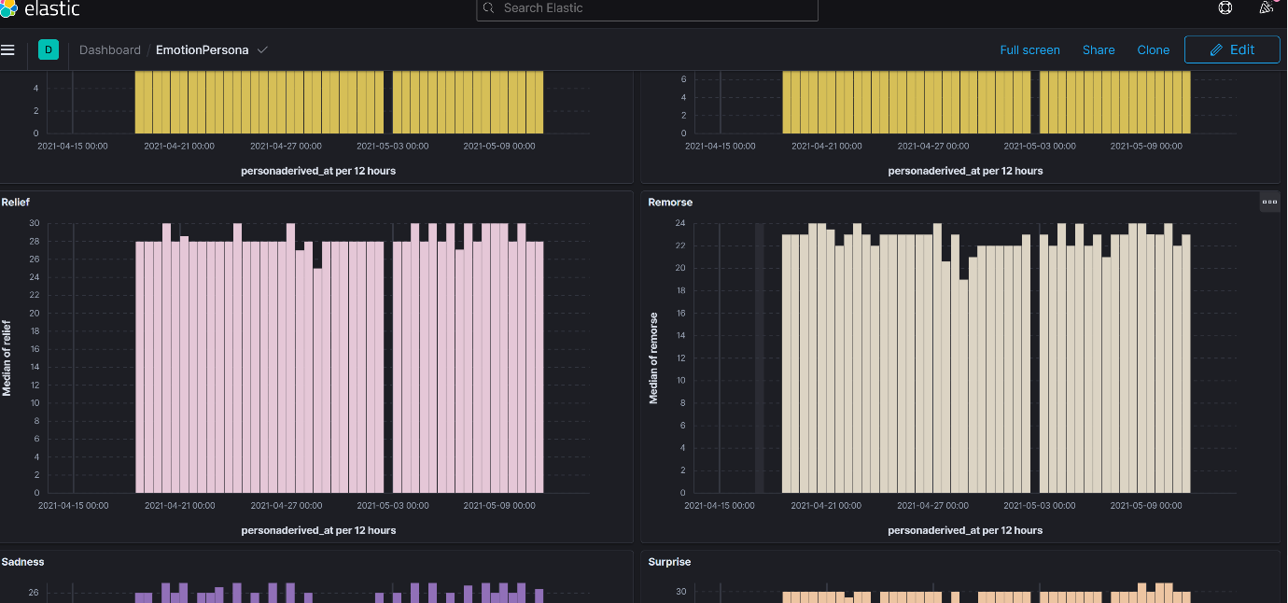

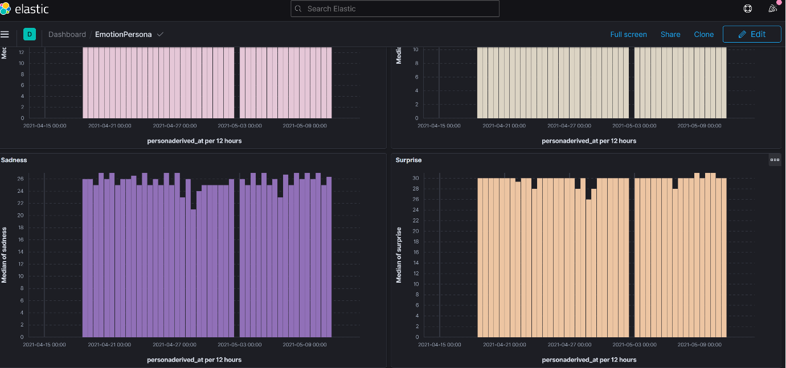

9)Surprise emotion level was high during covid 19 second wave.

Emotion Graphs can be filtered by different data points.

1)Top Emotions section wise

2)Top Emotions IAB segment wise

3)Top Emotion topic wise

4)Top Emotion geography (city/state wise)

5)Top Emotion by loyalty type

6)Top Emotion by website – Aajtak/Indiatoday

**COVID 19 plot – second wave patterns**

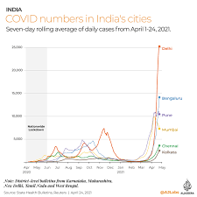

**Time series comparison can be done during covid 19 second wave with different reports described above.**

**(Different time intervals can be picked for splitting reports according to COVID 19 second wave plot)**